**The Gauge One 3-D Printing Circle**

**3-D Printing for Large Scale Model Railways –**

**A Guide**

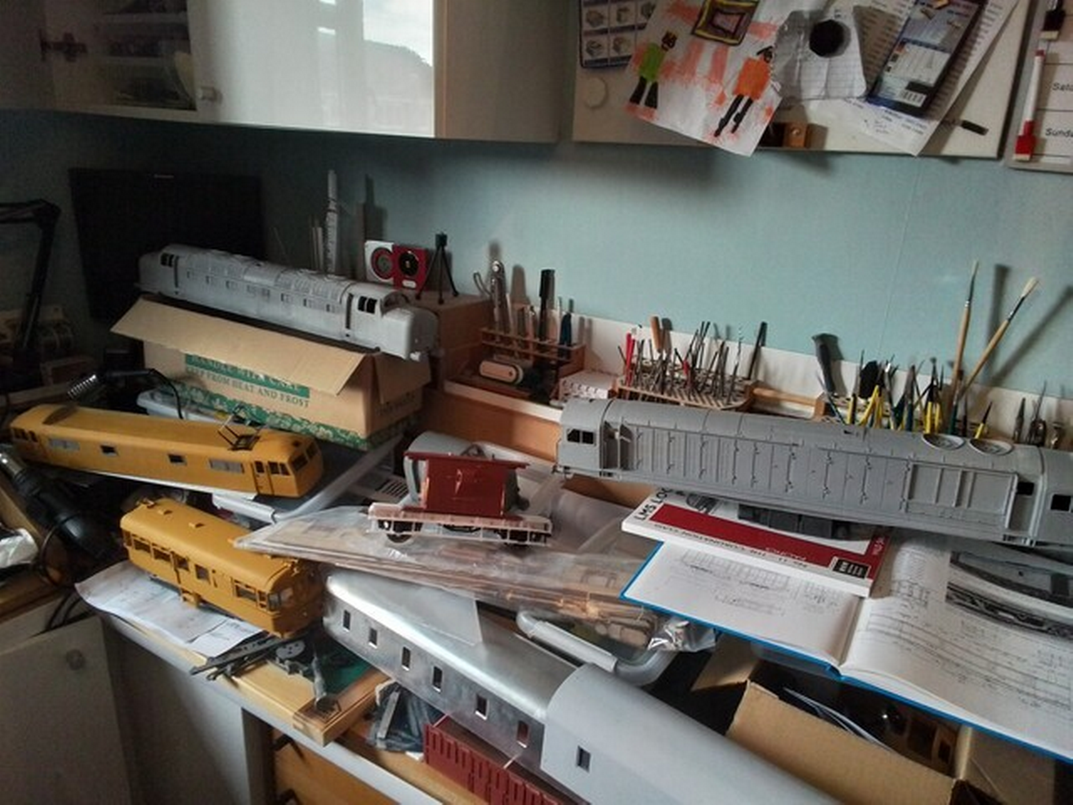

**First Edition**

**Published on 12th October 2024**

**Contents**

**1** **Introduction** 1

**2** **Using the Guide** 1

**3** **Disclaimer** 1

**4** **Background** 2

**5** **Purpose** 2

**6** **Feedback** 2

**7** **Glossary/Jargon Buster** 3

**8** **Where to Start** 5

**9** **Types of Printing (Overview)** 8

**9.1** **Materials Overview** 8

**9.2** **FDM (Filament) Printing Overview** 9

**9.2.1** **Advantages and Disadvantages** 9

**9.2.2** **Choice of FDM printer** 10

**9.2.3** **Materials for FDM Printing** 11

**9.2.4** **Nozzle and build plate temperatures** 11

**9.2.5** **Draught protection** 12

**9.2.6** **Clearing blocked nozzles** 12

**9.3** **SLA/DLP Resin Printing Overview** 12

**9.3.1** **Resin Materials** 15

**9.4** **SLS Printing** 15

**9.5** **SLM Printing** 15

**10** **Design and Printing Process (Overview)** 16

**10.1** **Summary of Steps** 16

**10.2** **Artwork Design** 16

**10.2.1** **Software** 16

**10.3** **Artwork For Filament Printing** 18

**10.3.1** **Preparation** 18

**10.3.2** **Hints and Tips** 21

**10.4** **Artwork For Resin Printing** 22

**10.4.1** **Preparation** 22

**10.4.2** **Hints and Tips** 23

**10.5** **Printing** 25

**10.5.1** **FDM filament printing** 25

**10.5.2** **Resin Printing** 30

**11** **Involvement of the Trade and Circle** 36

**11.1** **Design** 36

**11.2** **Availability of Artwork** 36

**11.3** **Availability of Printing Services** 36

**11.4** **Support** 37

**12** **Hints and Tips** 37

**12.1** **Design Techniques** 37

**12.1.1** **Part Work Designs** 37

**12.1.2** **Use of Lugs and Locating holes** 38

**12.1.3** **Creation of Large Radii Curves** 39

**13** **Areas of Interest** 40

**13.1** **What Parts of the Process do you Want to do Yourself?** 40

**13.2** **Artwork Design Experience?** 40

**13.3** **Room to do Printing?** 40

**13.4** **Availability of Spare Parts and Materials?** 40

**13.5** **Planning** 41

**14** **Useful Links** 41

**14.1** **Disclaimer** 41

**14.2** **3D Printing Introductory Articles** 41

**14.3** **CAD Software Selection Options** 41

**14.4** **Printer Selection Choices** 42

**14.5** **Printing Materials** 43

**14.6** **FDM Infill Densities** 43

**14.7** **FDM Printer Nozzle Cleaning** 43

**14.8** **FDM Support Setting** 43

**14.9** **FDM Printer Enclosures** 44

**14.10** **SLS Printing Processes** 44

**14.11** **SLM Printing Processes** 44

**15** **Conclusion** 44

# **Introduction**

This document came about following a number of queries within the Gauge One 3D Printing Circle about various routine and basic, but nonetheless, compelling questions on the process such as, critically and typically, “what printer should I buy?”.

Whilst answers were provided on each and every occasion this and other relevant questions were asked, there was a growing view that a live reference document could have a place as a go to document to provide further support and advice. The intention is to provide a facility for questioners to obtain answers and, importantly, help them to answer other relevant questions they wouldn’t necessarily appreciate also need resolution as well.

These include questions that they should be asking of themselves. Critically, the questioner’s ability to answer a number of these can only be properly considered once a reasonable understanding of what is involved is gained. Hence this document.

This is the first edition of this document and it just scratches the surface of what is a vast topic. Thus, as stated below, it is intended that it will be regularly updated. Accordingly, the intent is that the next edition will be released in early to mid 2025 at which point it is hoped that more material will be forthcoming to add to the document. Of course, this is in the hands of those practitioners whose knowledge and experience can add value and their willingness to share that information.

To those who have already contributed to this edition, a big thank you. Without you we would not have got this far with the document.

# **Using the Guide**

The Guide has been laid out in what is hopefully a logical sequence of information with the intent that the reader can follow it with reasonable ease. To assist in this there are a number of features available to help the reader if reading this in PDF format:

* Sections relevant to FDM printing have brown text.
* Sections relevant to Resin printing have blue text.
* The list of contents can be clicked on any section and the software will take you there immediately.
* All the cross references within the text are likewise clickable with the same outcome.
* All the links in blue are also clickable and will take you to the site with the proviso that you have internet access.
* There is a search facility in the top toolbar that allows basic searches for keywords/phrases.

# **Disclaimer**

Whilst all reasonable care has been taken in preparing this document, the information provided is done so without prejudice. This includes the links to external sites and any information contained therein.

Thus, neither the Circle and/or its members, accept any responsibility for the information provided. It is the sole responsibility of anyone using this information and the links to determine the reliability of the details provided and any risks and consequences arising from its use. No liability for the use of this information will be accepted by the Circle or its members.

# **Background**

3D printing is a relatively new process that lends itself to the creation of highly detailed and potentially unique models particularly in the larger scales of railway modelling. The Gauge One 3D Printing Circle (The Circle) was created in 2019 to provide a forum for interested individuals to partake in discussion and development of the processes in this rapidly growing activity.

The Circle is affiliated to the Gauge One Model Railway Association and both bodies can and do act as a catalyst for participant interaction between the groups. Based on the increasing interest in both areas of this activity, there is clearly a long-term future for the combined interest in 3D printing for larger scale model railways.

As noted in the introduction to this document, the need for a guide to assist newcomers has become more and more apparent to members who have already trod the path of involvement in this enthralling activity (Warning: it can be addictive!) Thus, the Guide has been developed to help those interested in or just starting down this path for themselves.

# **Purpose**

As stated above, the intent of the Guide is to provide a pathway to help those interested in 3D printing to start out and get up and running. As such it gives ideas on how it can be done. However, there are many strands to this, so it is, deliberately, not a document that will tell you what to do. Instead, it gives ideas and provides options, including posing questions newcomers should ask of themselves, to assist them to get the best out of the process in a way that suits their desires and circumstances.

In short, there is no one correct solution. Different needs and desires will produce different solutions. The important point is to ask the right questions at the beginning. Hopefully, the Guide will provide a route to the best outcome to meet the desired outcomes.

In addition, it seeks to provide solutions to potential pitfalls and also ideas on handling challenging areas of the process.

In all of this, the Guide recognises that the arena of 3-D printing is rapidly developing and expanding. The probability is that this expansion will continue for the foreseeable future. Thus, it is intended that the document is a live creation continuously updating itself to keep abreast of these developments.

# **Feedback**

To meet the above conditions, feedback from all comers is welcome. However, to maintain consistency and structure within the document it is important that this be managed to maintain a consistent and robust document. Please contact [3dguide@g1-3d.uk](mailto:3dguide@g1-3d.uk) with any comments/feedback you wish to provide.

# **Glossary/Jargon Buster**

**3D Model** Used both to describe the virtual model within the various software stages and the physical printed 3D model.

**Artwork:** The design that controls what is printed. There are three types of file used to store artwork in computer memory at different stages of a 3D project; design files, STL files and slicer files.

**Build Plate:** The plate within the printer on which the print is mounted whilst printing. Also known as the ‘print bed’.

**Build volume:** All 3D printers have maximum size limits for each axis on the size of model it can build. These are usually expressed in millimetres in XYZ order, e.g. 230mm x 220mm x 200mm. For model railways, being able to print long rail vehicles such as carriages is a particular interest. So, while 200mm x 200mm is suitable for two dimensions, the third (Z) dimension to cater for up to 700mm is an aspirational goal.

**CAD** Computer Aided Design.

**The Circle** An abbreviation of the Gauge One 3D Printing Circle within this document to make easier reading.

**The Cloud:** An internet-based data storage facility increasingly being used to store information remotely from a PC. The advantages are that the data is kept secure and is automatically saved at regular intervals. Thus, no back up is necessary. The disadvantages are that internet access is required and the system provider needs to keep supporting the service. They go, the data goes.

**Contour Lines:** Layer lines that are formed between the printed layers created by the slicing software. These tend to be more noticeable with FDM prints.

**Design files:** These store the software model artwork & differ between CAD software packages. The software will also transform these files into the STL files needed for the slicer when ready for this step.

**Elephants Foot:** A bulge at the base of the print that particularly develops when a print is mounted directly onto the build plate. Using scaffolding and independent platforms negates this problem.

**Facet:** A small flat area used in multiple at varying angles to form curves.

**FDM Printing:** Fused Deposition Modelling or filament printing.

**FEP:** Fluorinated Ethylene Propylene. A vital component in most desktop resin 3D printers. It refers to the polymer sheet located at the bottom of the resin tank. This transparent sheet allows light to pass through and cure the print layer being formed. It enables each cured layer to peel away cleanly as the build plate rises up between layer curing before coming down again to form the next layer.

**Filament:** Thermoplastic Polymer supplied as a reel of plastic thread or wire for FDM printers.

**Gcode files:** These **c**ontain the detailed coded steps to drive FDM printers and are the output files produced by slicers for these printers.

**Ironing** This is a process used in FDM printing to smooth out contour lines. To achieve this, the print head repeatedly covers the same surface slowly extruding plastic to fill in any voids between previously extruded strings of plastic.

**Magnetic Build Sheet:** This is a magnetic plate that can be attached to the standard build plate (print bed). Using this allows easier separation of the finished model since it can be simply pulled of the main build plate. Once off, the magnetic plate is simply flexed which should cause the model and scaffold to immediately detach. A word of caution: delicate items may be too fragile for this sort of treatment and traditional cutting off is advised for these.

**PEI** Polyetherimide: A coating applied to magnetic build sheets to aid adhesion.

**Platform/s** A system of flat pads designed to hold the scaffold and resulting prints to the build plate. It is used in conjunction with scaffolding, see below.

**Print Bed** An alternative term for ‘Build plate’ (see above) particularly used for FDM printing.

**Resin Tank:** The container that holds the liquid resin that the build plate is dipped into, to build up the print layers in the resin printing process.

**Scaffolding:** A support structure system of plastic that is developed by the slicing software for FDM and resin printing processes to hold the structure in place and together whilst it is being printed. The software controlling this allows manual modifications to be made to this if desired.

**Scaffolding Pin Cushion Effect:** A collection of pimples left after the removal of scaffold support from a print.

**Slicing:** The process by which an STL file is sliced into layers ready for printing. For FDM printers this comes in the form of Gcode. The thickness of these layers can be adjusted. The thicker the layer, the coarser the print. However, it will print more quickly. The thinner the layer, the finer the detail and the finish will be smoother. However, it will take longer to print. Slicing programs typically have many options, such as different speeds for different layers and supports for overhangs.

**Slicer files:** Output from slicing software. These contain the information to create each layer or slice of the model as detailed coded steps to drive 3D printers.

**SLA Printing:** Stereolithography also known as vat photopolymerisation, optical fabrication, photo-solidification, or resin printing.

**SLM Printing:** Selective Laser Melting (SLM) Process - Metal 3D Printing similar to that described below as SLS printing.

**SLS Printing:** Selective Laser Sintering (SLS) is an additive manufacturing process that belongs to the powder bed fusion family. In SLS 3D printing, a laser selectively sinters the particles of a polymer powder, fusing them together and building a part, layer by layer. The materials used in SLS are thermoplastic polymers that come in a granular form.

**STL file:** A file format that allows artwork to be downloaded from the design software for use in the software that prepares the design for 3-D printing. The acronym is an abbreviation for stereolithography. An STL file describes a 3D object as a set of 2D triangles.

**SVG file:** Scalable Vector Graphic File suitable for computer assisted cutting and/or engraving.

# **Where to Start**

3-D printing for model railways, particularly with rolling stock, creates a need for complex shapes often involving curves with significant levels of detail. Supporting such shapes during the printing process can often be a challenge along with some of the finer items such as handrails and rods. These are important matters to think about when considering the options set out below.

The first questions to ask oneself are:

* What is it I am looking for? For example:
  + 3D printing as a tool to create parts of a model that also use other systems/materials, or
  + 3D printing as the primary means of creating a model (N.B. some practitioners are aiming to produce all parts of a model as a 3D print and some extreme cases as a single print).
* Do I enjoy creating artwork? If not, there are a number of designs that are made available (free and otherwise) that can be used to make prints.
* Do I enjoy doing the printing myself? The alternate path a number of practitioners follow is to use the trade to do the printing of their designs.
* Is this a pastime for its own sake or is it simply a means to obtain railway models more easily/cheaply? A number of practitioners are simply front-end users who just follow the manufacturers settings and guidelines to produce their prints. Others delve deeper and experiment with settings to explore various possibilities.

From here, the following questions need to be considered:

* If doing my own designs, what software should I use?
* If doing my own printing, what printing system should I use? Tied in with this question will be the “all practical element” of how much space do I have?
* Finally, what type of print material/s should I go for? e.g. plastics, metals. The options available are increasing as well.

Only when the above questions have been answered, should the specific printer and accessories be considered, if necessary.

The sections below give guidance to finding answers to all the above questions.

One point to note is that the printers and artwork preparation programmes come with numerous options on the specific settings available e.g. layer thickness, speed, temperature (FDM printers), timing, scaffolding options, etc. It is best to stick with the manufacturers’ default settings except where the material type defines particular requirements (normally these will amend automatically when the material type and printer specifics are entered in the printer slicer program) at least until some experience has been gained.

If doing one’s own printing, a useful initial approach is to start with test pieces to make sure that all is well. To assist with this, there are usually test example STL files that come with the printer and also on the web. Once the printer has been tested, it is a good idea to try printing a straightforward model such as a wagon available from the Web. N.B. The Circle has a number of these on their website free of charge which are ideal for this purpose. They have been thoroughly tested before uploading and can be relied on to work on the assumption the printer is operating correctly. Typically, this will only cost a small amount in material consumption and will boost confidence further, assuming all goes well.

If issues do arise, the Circle members will be keen to assist with the resolution of these.

As confidence and experience grows, producing specific designs can also be considered if this is an area of interest. There are numerous options in regard to software. There are also numerous video tutorials to help. All these can be found on the Internet particularly through YouTube testimonials.

In addition, there are also an increasing number of STL files of models available, both free and at a price, that allow predesigned models to be created at will.

It is worth noting that print times can be extensive. 10 hours and above is not uncommon. However, printing can be done overnight, whilst at work or undertaking any other task that requires attention. Thus, the actual printing time will not require any input after starting unless something untoward occurs.

Once the print/s are complete, they will need to be finished, assembled as necessary, filled, sanded and painted as with any constructed kit or scratch built model. Most of the plastics used in the process take glue and paint well. However, as with any plastic kit, it is best to avoid exposure to sun even through a window since this could induce warping/deformation through softening of the plastic.

Adhesives to join parts such as superglues and/or epoxy resins are ideal.

Openings for bearings and/or axles can be incorporated in the print. However, these may require opening out after printing to ensure a free fit.

3-D prints are typically quite light and may be susceptible to long term warping/deformation particularly when exposed to heat. Incorporating reinforcement helps prevent this.

There are a number of different materials available, each with varying properties. Some of these have been listed in sections 9.2.3 and 9.3.1 together with their attributes. More will be added in future releases of the Guide. Section 14.5 also has links to external website with more information.

One point worth remembering is that the parts only cost a small amount to print. So, if things do go wrong, whilst resolving the issue may be complex and time consuming; generally, in terms of material, not a lot of money has been wasted.

N.B. The processes, once established, can quickly become addictive and result in the production of a lot of models that have been produced cheaply and relatively quickly allowing for print times.

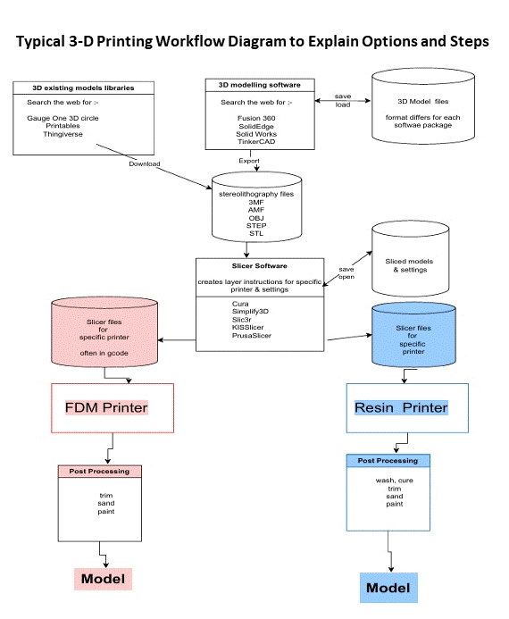

# **Types of Printing (Overview)**

3- D printing forms objects by building up layers of plastic to create three dimensional shapes of any form one chooses. The processes creating the shape are determined by the artwork supplied to the printer. Creating the artwork is dealt with in section 10.2 below.

There are a number of forms of 3-D printing. These are:

* **FDM or Filament Printing.** As the name suggests, this uses a solid plastic filament (most commonly 1.75mm diameter) which is fed through a print head (the “hot end”) which melts the plastic. This is then forced through a small nozzle at a rigidly controlled rate. The molten plastic is extruded at points controlled by software driving X and Y plane stepper motors. These locations are determined by the sliced artwork file. The model is built up in layers from a build plate. To achieve this, the print head is precisely moved around the X and Y planes. One layer at time is printed in the X-Y plane. As each layer is completed, the print head usually moves up the Z axis to the next layer. However, in some cases, the printers lower the bed and maintain the print head at the same height when starting a new layer. The slicing software controls the rate of extrusion and speed of movements based on the printer settings. These differ for each model, nozzle size and layer height. They are set whilst setting up the artwork for printing. Section 10.3 below provides more information.
* **SLA/DLP Resin Printing.** This involves a pool of UV light sensitive resin contained in a tank, into which a build plate is dipped. The base of the resin tank is clear and likewise, the tank rests on a clear glass plate. When the build plate is pressed against the bottom of the resin tank, UV light is shone through this plate in areas where the artwork for the layer shows a solid section/s. The resin trapped in this area/s is exposed to the light and thus solidifies against the build plate or, after the first layer, the previous layer.
* **SLS or Selective Laser Sintering Printing***.* In this process, a thin layer of fine plastic powder, commonly nylon, is spread over the entirety of the build surface and a laser fuses the powder in the areas that are intended to be solid. The build surface is lowered by the height of one layer and the process is repeated. At the end of the printing process the solid parts are separated from the loose powder and cleaned up using air jets and media blasting.
* **SLM or Selective Laser Melting Printing.**This is a similar process to SLS. However, the powder is metallic.The result is a solid metal part. Metals used include aluminium, brass, stainless steel and titanium. There are many other metals available as well. SLM 3D printers are extremely expensive so are only feasible for commercial operations. However, there are agencies who now offer printing services aimed at the hobbyist at relatively reasonable prices.

There are some links to external websites providing further information in section 14.2.

## **Materials Overview**

Materials available for printing are extensive and increasing. Each come with positive attributes and challenges. At present plastics in various forms are available for both FDM (filament) and SDA/SDL (resin printing). Most are typically suitable for home use with sensible precautions as outlined below.

Metals as used in the SLM process are usually reserved for commercial operations and generally give coarser detail at present. On the other hand, they are stronger and less susceptible to deformation. Currently, they are also more expensive than plastic.

Many of the commercial printers list the various products available together with their attributes. It is worth researching these sites even if not intending to use them to get some idea of what is possible. The FDM and resin printing sections 9.2.3 and 9.3.1 below, provide more details of the various materials available for each type of printing process together with their attributes.

In addition, links to external websites in section 14.5 provide more details.

## **FDM (Filament) Printing Overview**

Fused deposition modelling (FDM) is a material extrusion method of additive manufacturing where materials are extruded through a nozzle and joined together to create 3D objects.

FDM is an old technology, as any pastry chef who has created a fancy cake will state. In its original form, soft icing is extruded through a piping bag to add decorative bits to a cake. The first layer goes straight onto the cake & the next layers build up the 3D image required.

Thus, FDM technology requires:

* a material that can be extruded
* a motor or pump to move the material & pressure the extrusion head
* if solid, a heater to melt the material
* an extrusion head to create a flow of a precise size
* devices that can position the extrusion head where required to create the planned output.

FDM systems have evolved to allow the extrusion of other materials. On a far larger scale, this includes rapid setting concrete to create structures including buildings, layer by layer.

For our purposes FDM printing uses:

* a reel of plastic filament
* a motor system to force the filament into the print head
* a print head that can melt the filament & extrude it
* stepping motors that can position the print head + & build plate in X. Y. & Z axes.

For further information see section 14.2: “What Is FDM 3D Printing? – Simply Explained”. This has a good write-up of the process and is the source of the diagram below.

### **Advantages and Disadvantages**

FDM printers can produce good results, especially if consideration is given to layer height, orientation and supports. There is usually a trade-off between the time taken to print and the quality of the finished article. By using finer layer heights, acceptable results can be achieved. However, printing times will be extended as result of this. FDM printers also offer a wide choice of materials.

The positive elements of a FDM printer are:

* It can be used in the home.
* Very little mess.
* Generally, there is no smell.
* They are typically a good size for most G1 models.
* All the printer needs is a flat surface and a warm room.
* Setting it up is generally straightforward.
* Like for like, generally the cheapest option for 3-D printing.

The negative elements of a FDM printer are:

* The quality of finish and detail is generally lower than that of a resin printer.
* Nozzle blockages can be an issue.
* Layer connections along the grain can be quite weak compared to resin.
* There is a potential for stringing which will increase clean up times post printing.

### **Choice of FDM printer**

**Build volume**

The typically build volume for FDM printers tends to be larger than other forms of printer.

Most printers tend to cater for a build volume which is more or less a cube, so to be able to print a typical railway coach (say 600mm long) in one piece the printer would need to be either far longer and/or taller (and thus potentially expensive).  However, there is one form of FDM printer which is designed to cater for one long dimension – the belt printer.  These have a theoretically infinite dimension along the belt.

In addition, a member of the Circle is currently experimenting with an extended Z axis FDM printer which has the capability of printing items up to 850mm tall.

It is fair to say that the above printers have created glitches. These include:

* Wobble along the Z axis for the tall printer and
* Distortion of the print at the time that the initial separation of the print end from the belt occurs.

However, these issues are being worked on and no doubt will be resolved in the fullness of time. For the moment, they are probably best used once some experience has been gained. 

**Filament Feed**

The main choice is between:

* bowden tube systems, driving the filament from the drive system through a hollow tube to the print head, and
* direct drive, where the filament drive occurs on the print head itself.

Generally, the direct drive system is preferred since it is less prone to jamming.

**Maximum temperature of build plate and nozzle**

To be able to print in materials that are at less risk of warping in the sun, the printer has to be able to heat the bed to at least 80°C (preferably 100°C) and the nozzle to 250°C.  Section 9.2.3 covers the various FDM materials available and their properties. There is also a link to an external website on the subject in section 14.5.

**Build plate**

A magnetic build sheet is recommended to make it easier to remove the model after printing and reduce the risk of damaging the print bed.  Having a choice of different build sheet surfaces is also useful. Section 10.5.1 provides more information on this subject.

### **Materials for FDM Printing**

There are a number of different plastics available as filament for FDM printing. Their different characteristics can affect:

* how easy they are to print with,
* the appearance of the final print, and
* the finished article’s strength and resistance to deformation.

|  |  |  |  |
| --- | --- | --- | --- |
| **Material** | **Nozzle/Bed temp °C** | **Advantages** | **Disadvantages** |
| PLA | 200/50 | Low melting point, so easy to use, flows well so usually gives a good finish. Less prone to warping. Quite strong. Odourless. | Finished models can soften and warp on a sunny day.  Brittle.  Absorbs moisture. |
| PETG | 240/80 | Glossy finish  Adheres to bed well  Low odour when printing. | Tends to cause stringing when printing. Driving wheels tend to slip because of lack of grip. |
| ABS | 250/100 | Finished models are strong, waterproof, and not prone to deformation in the sun. | Prone to warping during printing. May be dimensionally inaccurate. Requires an enclosure.  Strong odour when printing.  Not all printers can reach required temperatures. |
| HIPS | 245/100 | Similar to ABS but lighter and more dimensionally stable. | Similar to ABS. |
| Wood filled PLA | 200/50 | PLA containing up to 30% wood fibres. Can give a wood like appearance to finished model. | Can clog nozzle  Wood like finish is debatable. |
| Metal filled PLA | 200/50 | PLA containing metal powder (e.g. bronze, stainless steel etc). Models give the appearance of the specified metal if polished. | Requires hardened steel nozzle.  Can clog nozzle.  Prints are still generally plastic and thus not particularly strong. |

There is also advice on printer materials given in links to external websites outlined in section 14.5.

### **Nozzle and build plate temperatures**

Different materials require different nozzle temperatures, and more significantly, different build plate temperatures, to allow satisfactory adhesion. Generally, the lower the temperatures required, the easier it is to get satisfactory results. N.B. some printers do not have the capability to reach the temperatures required by certain materials.

### **Draught protection**

Draughts can cause uneven cooling of a print while it is being formed. Some materials are prone to significant warping as a result. For this reason, it is recommended that screens are used to enclose the print area if printing with these materials. Section 10.5.1 gives more information on this subject.

### **Clearing blocked nozzles**

This is a common problem with FDM printers. Nozzles need to be regularly cleaned to avoid this issue. More information can be found in the link in section 14.7.

## **SLA/DLP Resin Printing Overview**

The resin being a liquid, smooths out the joints between the layers to give an almost uniform surface. As such, it gives a much finer finish than the typical FDM process.

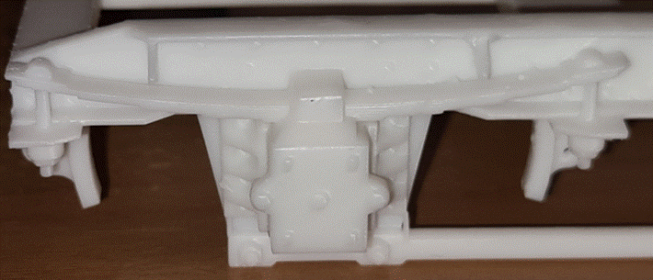

*The level of detail possible with resin printing.*

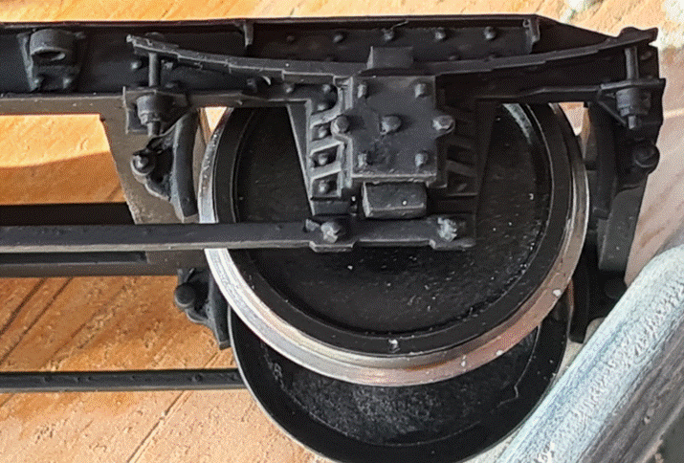

*Painting really highlights the detail. N.B. the wheel suspension is fully expanded pushing the axle boxes down to the keeper bars since there is no load on the wheels as yet. Normally the springs within the axle boxes will compress under load thus hiding the functional boxes and lining up the wheels with the brake pads.*

As the print builds up, the build plate gradually rises out of the resin tank thus gradually revealing the print.

Since the print is hanging down from the build plate, it is vital that it is well supported. This is achieved with “scaffolding”. The scaffolding is generated using the printing preparation software discussed in section 10.4.1.

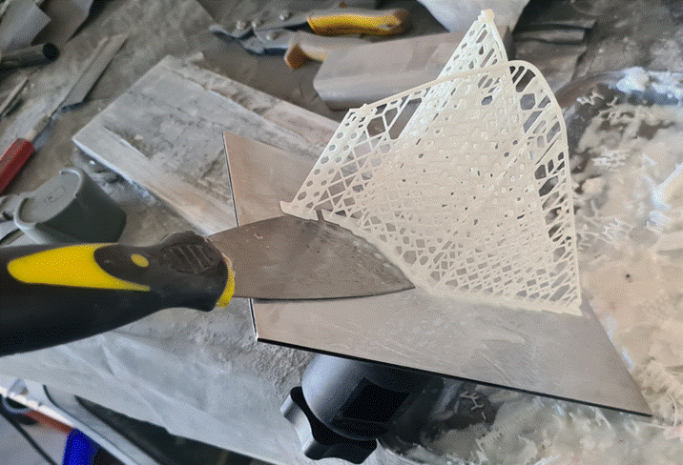

*Carefully removing a completed print together with its scaffolding from the build plate using a flat blade to slide under the platforms holding the scaffold to the plate. The print itself was for carriage roof pipework and fastenings that follows the complex curved profile of the roof. Given the delicate nature of the print, the scaffolding was vital to hold everything together during printing.*

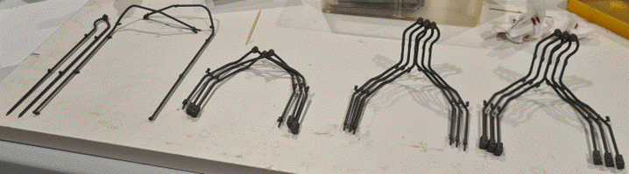

*The completed pipe sections following washing, curing and painting; ready for fitting. This illustrates another advantage of 3-D printing: repeatability. There are a number of pipe sections in the photo that are the same. Indeed, one is a mirrored version of its mate. This was achieved by inverting the artwork before sending it to print, simple!*

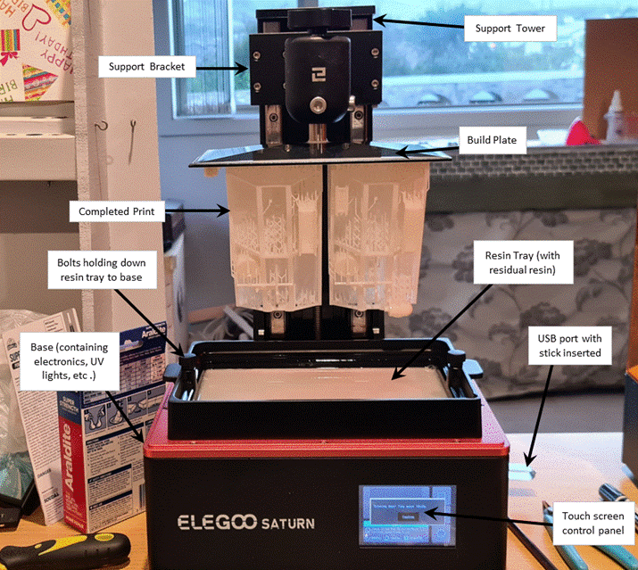

*The anatomy of a resin printer.*

### **Resin Materials**

There are links to websites with advice on various materials in section 14.5.

## **SLS Printing**

Selective Laser Sintering is a relatively new technology that can produce high quality plastic prints. However, it is currently beyond the reach of home production for most hobbyists. As a result, this is an area that is best done by commercial organisations who offer printing services in this medium. More information on the process itself can be found in the link provided in section 14.10.

## **SLM Printing**

Selective Laser Melting is also relatively new and focuses on printing in metal. As with the SLS process outlined above, it is currently beyond the reach of home production for most hobbyists. Thus, this is also an area that is best done by commercial organisations. There are extensive options available in metal types. Fortunately, there are now organisations who will accept small orders for SLM printing. Early experiences indicate that the finish quality is somewhat coarse. However, dimensionally, the prints do appear accurate. Moreover, they seem to be reasonably strong. Most prints undertaken thus far by members have been done in aluminium. The costs, whilst more than plastic, appear to be reasonable and comparable with traditional metal kit offerings. One member has also obtained prints in stainless steel for small component parts (buffers) for a far more significant cost. It is early days for this technology for the hobbyist. However, the signs are encouraging for the future. More information on the process itself can be form in the link provided in section 14.11.

# **Design and Printing Process (Overview)**

## **Summary of Steps**

To produce 3D printed models the following steps are involved.

**Artwork Design (using CAD software)**

By using the designs of others, shared in the form of STL files, this step may be avoided. Alternatively, if the actual printing is going to be done by a third party, this might be the only step carried out by the individual.

This step is common to all 3D printing technologies. Models for 3D printing are designed using 3D Computer Aided Design (CAD) software.

Designs for the completed model (or the parts which comprise the final model) are typically output in the form of STL files.

There are links leading to advice on software packages in section 14.3.

**Preparation for printing (using slicing software)**

This step varies for different printing technologies, and in some cases, for different printer models. To prepare files for printing, the STL files need to be processed through slicer software. This involves arranging the 3D objects on the build plate, orienting them for successful printing, arranging supports, and potentially setting different printer parameters. The result is then “sliced” to produce the instructions for the printer. Finally, these instructions are downloaded as a file and copied to the printer.

**Printing**

The printer is cleaned and set up ready for printing. The file output from the slicing step is selected on the printer, filament or resin is loaded, and printing is started.

**Post Printing**

The completed print is removed from the printer and finished as necessary, and the printer is cleaned up.

## **Artwork Design**

### **Software**

There are a number of programmes available to develop artwork. These range from hugely expensive and sophisticated professional CAD programs down to more user-friendly but more basic free ware. There are also sites on the web giving advice on the options. Some of these are listed in section 14.3. These list the pros and cons of each system based on the author’s experience of the software. These are definitely worth looking at to see what is available and what each can do.

However, there are some commonalities that are considered here:

* Firstly, the more sophisticated the software is, the more it will do. Conversely, it will be harder and more time consuming to learn.
* Consider whether the software chosen may cease to be available in the future. Although some commercial software is available in free “community” or educational versions, it may be that access to the software may be withdrawn or have to be paid for, in the future.
* CAD software is, by its nature, complex and can take a lot of learning. Although the principles of 3D design are unlikely to change, finding the same features in different software programs may take quite a bit of learning. Consider the amount of support available for your chosen software.
* Most freeware systems run on a cloud-based system. This means your files are stored on the Cloud and your access will depend on the software owner continuing to support the system and allow free access. Some keep the files private, others store them on a public platform.

Free packages include (N.B. some of these may not be suitable for 3 D printing):

|  |  |  |  |
| --- | --- | --- | --- |
| **Model** | **Beginner** | **Best for 3D Printing** | **Used by Circle Members** |
| 3D Builder |  |  | Yes |
| 3D Slash | Yes |  |  |
| Autodesk Maya & 3ds Max |  |  |  |
| Blender |  | Yes |  |
| BricsCAD Shape |  |  |  |
| DesignSpark Mechanical |  |  |  |
| FreeCAD |  | Yes |  |
| Fusion 360 |  |  | Yes |
| Meshmixer | Yes |  |  |
| Morphi | Yes |  |  |
| Onshape |  | Yes | Yes |
| OpenSCAD |  |  | Yes |
| Prusaslicer |  |  | Yes |
| PTC Creo Elements/Direct Modelling Express |  |  |  |
| SelfCAD |  |  |  |
| SketchUp Free | Yes |  | Yes |
| SolidEdge Free |  |  | Yes |
| SolveSpace |  | Yes |  |
| Tinkercad | Yes |  | Yes |
| Wings3D |  | Yes |  |
| ZBrushCoreMini |  |  |  |

For a newcomer, a basic programme such as “Tinkercad” could be employed as an initial software design system. The benefits of this are that:

* it has a really good suite of tutorials to guide a user through the processes the software offers.
* It is reasonably straightforward to pick up (essential for someone trying to pick up the nuances of artwork design).
* It is intuitive and user friendly.
* Dimensionally, it is accurate.
* As an aside, it is also suitable for creating 2-D files for electronic cutting using hardware such as the Cricut machine.

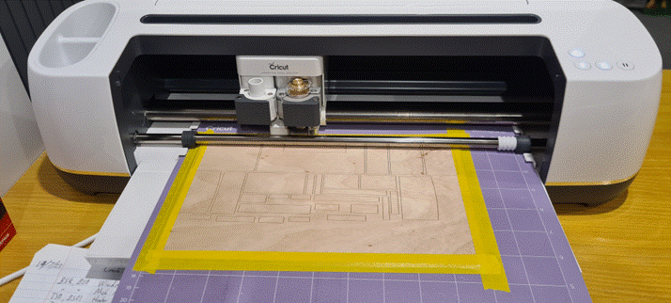

*A Cricut machine with 1mm birch ply, complete with internal sections cut out using Tinkercad artwork downloaded as an “SVG” file.*

The disadvantages are:

* It struggles with large radii curves. These come out as a series of flat facets which are quite crude in appearance.
* File sizes can be an issue with speed. N.B. despite this, it is capable of managing files with the type of detail and sophistication needed for model railway items.

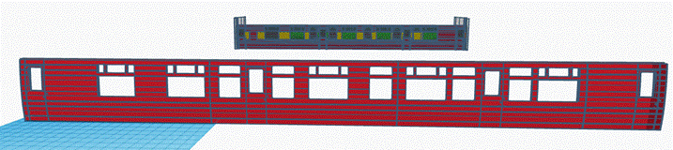

*Tinkercad artwork for a carriage side ready to be cut into sections to fit into the printer. In the background is the design master.*

Whatever system is used, it will then allow a completed file to be downloaded which will need to be saved as an STL file for printing.

**N.B.1:** for cutting, the files should be downloaded as SVG files. This will force the profile of the artwork into a two-dimensional shape based on the plan view of the artwork.

**N.B.2:** once downloaded, the resulting file (STL or SVG) cannot be easily amended. However, the original artwork remains on the Cloud and can still be altered if necessary.

## **Artwork For Filament Printing**

Most printers come with freeware to do this.

### **Preparation**

**Print orientation:** Orientation of the model when arranging the object in the slicing software is particularly important. Filament printing tends to produce a distinct grain in the printed object. This has an impact both on appearance and strength.

**Finish:** Generally, the finished surfaces that are perpendicular to the build plate during printing, are better than the typical finish on surfaces parallel to the build plate. A flat surface parallel to the build plate has to be made smooth by a print nozzle extruding material only at a certain point. Some slicing software and/or printers offer a technique called “ironing” (see Glossary). Surfaces which are vertical during printing have a much more uniform appearance. Although the individual layers are usually visible, choosing a very thin layer thickness means that these lines are much less visible.

Another important consideration is that, because the amount of movement control in the X and Y axes is finely controllable, curves on or close to the vertical (z) plane also tend to be reasonably smooth subject to the layer thickness settings. However, as the curve approaches the horizontal planes (x and y) the layer steps (contour lines) will become increasingly more obvious.

|  |  |
| --- | --- |
|  | *A slicer screenshot of the same object in different orientations. This shows how curves follow a smooth path when orientated so they are vertical, but show increasingly obvious steps as they approach a horizontal orientation.* |

**Strength:** Along the grain, filament printed objects tend to be reasonably strong. This is because the plastic was extruded in a continuous stream along this direction. However, the joins between new layers and the older, lower layers, involved molten plastic adhering to already solidified layer. As a result, these typically result in a weaker joint. Thus, FDM printed objects are at more risk of splitting along the grain of the printed layers. This should be considered when orienting the artwork.

**Infill:** To save both material and print time, FDM printing slicing software automatically defaults to producing an infill pattern in solid objects. The infill usually takes the form of a honeycomb pattern. This results in a strong and light structure.

The slicer software allows the following parameters to be specified/changed to facilitate the above process:

* The number of layers for the perimeter of the object,
* the percentage of solid material within the infill, and
* the pattern used to create the infill.

There is more advice on infills in section 14.6. This provides a link to an external website on the subject.

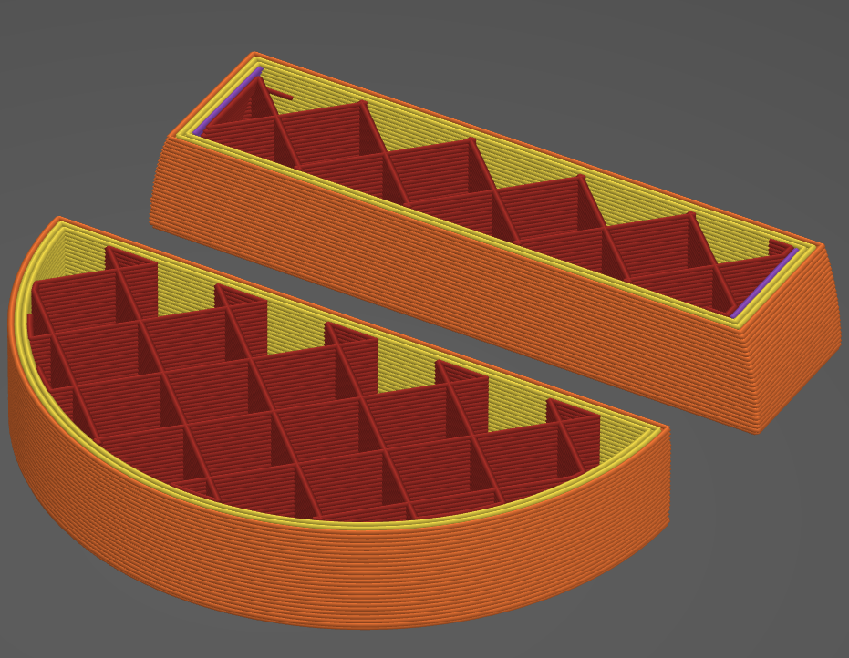

*A cross section across the same two objects showing the default infill pattern created by a Prusa Slicer*

**Supports:** Filament printers require models to be supported from the build plate, with each layer adhering to the layer below. Although FDM prints have some capacity to bridge small gaps, e.g. a window opening lintel, they can only do this by laying a string of filament in thin air from one side of the gap to the other. Inevitably, there will be a certain amount of sagging. In addition, because the layer has not been pressed onto one below, the finish will be poor and only acceptable for non-visible surfaces. Overhanging surfaces that are steeper than approximately 45° to horizontal can safely be printed by cantilevering each layer a little more. However, anything closer to horizontal is more likely to fail.

To enable such shapes to be printed, the slicing software can add supports. These are temporary structures, usually printed in a grid pattern, and designed to touch the finished model as lightly as possible. After the model has cooled these can usually be broken away, or if necessary, cut off. Inevitably they usually leave marks on the model’s surface which have to be removed, usually by sanding or filing.

There is a link to an external website offering more advice on the subject in section 14.8.

|  |  |
| --- | --- |
|  | *Artwork for an arch with supports added by the slicing software in green. Note that only where the undersurface of the arch is less than a stipulated setting does the slicer add supports. In this example 40° was selected. N.B. This can be amended within the software controls. The steeper sides will support themselves sufficiently to not need additional support.* |
| *Note the narrow gap in the supports at the centre of the arch. At this point the arch is horizontal. Thus, a single layer will span the gap without additional support. The issue lies with cantilevered layer ends over too long a distance. If these are left unsupported, they will sag.*  *N.B. This image is shown for demonstration purposes only. A better alternative for this particular example would be to invert the artwork vertically so that the arch can be built upwards thus removing the need for scaffold entirely. However, this option will not always be available and/or appropriate.* | |

### **Hints and Tips**

**Build plate adhesion and heated beds**

One of the biggest issues confronting newcomers, when starting in FDM 3D printing, is getting the print to adhere to the build plate and detaching it once it is finished.

When laying out artwork in the slicing software, it is important to consider how well it will adhere to the print bed (build plate) and whether parts of the model need additional support material. N.B. this will be removed after printing.

To achieve a satisfactory joint between the print bed and the print, the initial layer height needs to be considered. Most FDM printers have the ability to print a test pattern. This should be observed to ensure that the bead of filament laid down has been “squished” onto the build plate so that it is:

* neither squeezed into a thin film (the nozzle is too low),
* nor left as a nearly round string of filament just resting on the build plate (the nozzle is too high).

A first layer which has been squashed to about half the diameter of the unextruded filament is typically about right.

Bed adhesion depends on a reasonably large proportion of the model and/or scaffold platform/s being in contact with a clean print bed. Before starting a print, it is important to check that the print bed is clean. Fingerprints can be particularly detrimental to good adhesion. Avoid touching the print bed if at all possible. If it has been touched, clean the print bed surface. Effective cleaning can be achieved using a household glass cleaner. It is also possible to use isopropanol (IPA),

Excessive bed adhesion also needs to be considered. FDM printer build plates have evolved quickly in recent years. Early printers had fixed build plates with no heated bed. First-layer adhesion issues were solved using glue & sticky tape, with much experimenting and print failures. Heated beds now provide some control of first-layer adhesion. These can be adjusted to suit a specific filament. These beds grip the print strongly when hot, but release it when they cool down.

## **Artwork For Resin Printing**

### **Preparation**

The steps in this process are:

* The first time the software is used it needs to be set up for:
  + The printer being used.
  + The resin being used.
* Load the artwork onto the software build plate.
* Make copies as necessary.
* Align and angle the artwork to:
  + ensure that the artwork lies wholly within the build plate.
  + angle the artwork so that, as far as is possible, it is self-supporting. N.B. the closer to vertical it is, the better supported it will be. However, being taller means it will take longer to print.
  + ensure that any supports that are necessary, occur on faces that are hidden or not prominent.
* Then create the scaffolding using the scaffolding and support page. The software does this at the touch of a button.
* Finally, return to the first page and slice the artwork to create the layers. Again, the software does this at the touch of a button.
* Finally, save the file.

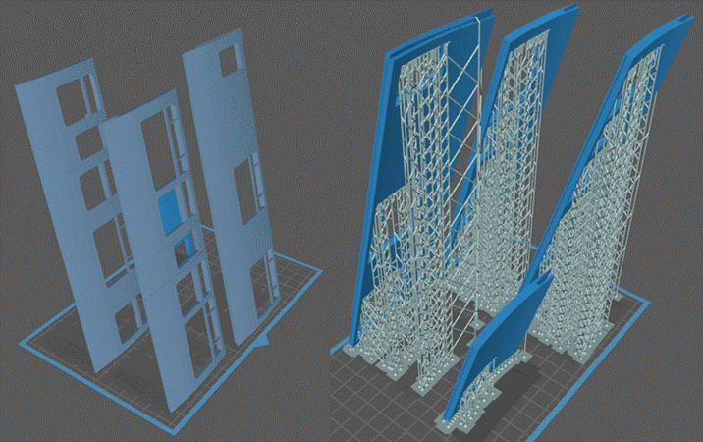

*On the left: carriage side sections downloaded as STL files and mounted on the build plate. They have been angled to ensure scaffold supports stay clear of external faces. This also minimises the amount of scaffolding required since most of the sides were self-supporting due to the steep angle. On the right, the scaffold has been added complete with platforms. The next job is to slice the artwork and then transfer the file to the printer ready to go. This particular example took 17 hours to print.*

### **Hints and Tips**

Note this section provides information intended to be helpful to individuals having potential problems with their prints. It has been built on experiences of individual practitioners who have previously encountered these difficulties and have worked out solutions to suit their own needs. Inevitably there will be differing ideas and thoughts on these.

This section makes no judgement on these and airs them without fear or favour on equal terms. Thus, it is important that individuals consider and/or try out the various ideas for themselves. They should draw their own conclusions as to what suits them best. In simple terms there is often more than one solution available. All are equally valid with the proviso that they work for the person using them.

**Mounting prints on build plates**

It is possible to mount prints directly onto the build plate. However, this can create some difficulties:

* Firstly, the prints can be difficult to remove from the build plate following printing.
* Secondly, having a scaffolding support structure between the print and the build plate appears to create a degree of resilience between the flexible plastic base (FEP) of the resin tank and the layer being printed which helps cushion the impact each time the print is lowered down to this. This does appear to reduce the risk of damage to the FEP.
* Thirdly, having the print directly mounted on the build plate creates a rib around the base of the print where it meets the plate. This is commonly known as an elephant’s foot which seems descriptive!

The scaffolding, whilst using more resin, appears to solve these problems. It is relatively easy to separate from the print as well since the connecting points are thinned down and have resin that is less dense, thus making them weaker and easier to snap off at these points.

Small detail parts are best mounted on platforms that can be interlinked to form a single raft. This has the following benefits:

* It keeps them together in one place and thus, less easy to lose.
* Being a larger object means it will be less likely to jam up in the cleaning tank.
* Being mounted on a scaffold sprue means they can easily be pre-painted if required.

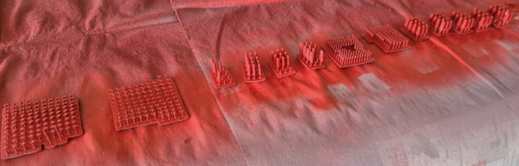

*Examples of detail parts mounted on combined platforms connected with individual sprues (a single stem of scaffold) which has eased washing, curing and spray painting.*

One other downside of using scaffolding on large plain areas, is it leaves a dimpled surface. The trick is to angle the print, as described, so that these, as far as is practical, are on surfaces that will not be visible. If this is not possible then leaving off projecting detail to allow ease of sanding during assembly is desirable. The protruding detail can then be added after the main surface is smooth and the main assembly is complete.

**An alternative approach to resin print mounting**

A different approach is to fit a magnetic build sheet to the machine’s own build plate. This allows prints to printed directly onto the magnetic plate. In turn this reduces the need for support scaffolding. The only supports required are for unsupported overhangs. This has both advantages and disadvantages:

Advantages

* Reduced scaffolding pincushion effect in surfaces built onto the build plate. These will be perfectly flat.
* Heavier objects can be rigidly supported by the build plate reducing distortion.
* Reduced wastage of resin.
* Reduced print times since the printed object is physically lower.
* Easier handling and release of models. Normally the magnetic build plate can be detached, cleaned and final curing done without detaching the model until the end. This will help protect it until it is fully cured. To detach the print the build plate can be flexed making detachment a much more straightforward operation. However, care will still be necessary for delicate prints where such forces may result in damage.

Disadvantages

* Artwork may require drainage holes to release resin trapped against the build plate.
* Detail against/close to the build plate may be lost.
* Printer settings need to be adjusted to minimise the “elephant’s foot” effect around the joint between the print and the build plate.
* May not be suitable for more delicate prints such as pipe work etc. due to risks when flexing the sheet following removal.

|  |  |
| --- | --- |
|  | *Artwork for a wagon underframe and headstocks (buffer beams) designed for printing against the build plate. These are viewed in the Chitubox slicer through the build plate, the areas in green being in contact. This shows the channels built into the artwork to allow the resin to flow in and out of the print during printing. The separate headstocks have been designed to dovetail into the underframe following printing (one spare!).* |

*The printed underframe still attached to the magnetic build plate.*

## **Printing**

### **FDM filament printing**

**Location considerations**

If the printer is not enclosed, avoid draughts. These cause uneven cooling and warping. Some printers are noisier than others, but few if any are completely silent. Since they can be working for hours or days at a time, siting them away from bedrooms or living areas is wise.

The printing process involves melting plastic. Some of these (e.g. ABS) produce noxious fumes. This is also a factor if using Isopropanol (IPA) for cleaning.

The printer contains heating elements involving relatively high currents. Although printers from reputable brands include monitoring and safety cutouts, A small risk of malfunction resulting in a fire is possible. Given the above points, siting the printer in an outbuilding is worth considering where practical.

More information on printer choices is provided in the links contained in section 14.4.

|  |  |
| --- | --- |
|  | **Enclosures**  When printing in materials such as ABS, an enclosure provides a more temperature stable environment by cutting out draughts and thus reducing the chance of warping by maintaining an even temperature across the print. The enclosure can also give a certain amount of protection in a typical workshop environment, if that is where the printer is sited. More information is provided below.  There is also a link to an external website giving more information on the subject in section 0.  *A homebuilt enclosure which sits on an IKEA trolley. The top and bottom boards are MDF with polycarbonate walls and doors. The brackets which hold it together are 3D printed.* |

The benefits of using an enclosure are:

* **Temperature stability:** An enclosure round your printer reduces susceptibility to draughts. In addition to natural wind, anything that creates heat will cause a thermal air flow. Thus, the bed of the printer, when heated, will create a column of warmer air to rise from it. In turn, this will draw in air from the surroundings. Any form of draught such as these can cause interruptions in the deposition of printer layers due to unwanted cooling of the filament as it is being laid down. Furthermore, a number of filament types require high temperatures for success. Thus, they are particularly susceptible to this phenomenon. This is particularly true of materials such as ABS.
* **Reduction of fumes/odour etc.:** Filaments also have a tendency to create fumes in varying quantities when heated. An enclosure will help prevent these spreading through the building. However, to obtain the maximum benefit from this, some form of extraction and filtering is also necessary. A further drawback is that this may also generate increased draughts.
* **Separation of hot areas**: An enclosure provides protection from hot parts. This importantly important when considering children and pets, as well as some adults who should know better. Touching the print bed can also lead to deposition of oils from the skin and poor adhesion of the filament to the bed.
* The machine does make sudden, unexpected movements whilst operating. Thus, just like any other machine with moving parts, an enclosure will reduce the risk of limbs, loose clothing etc. becoming trapped in the machinery.
* **Dust reduction:** Reducing the air flow around the printer can reduce dust deposition. This also applies when the printer is out of use, if the enclosure has a lid. Build-up of dust on the print bed can be a factor in poor adhesion of filament.
* **Fire prevention (smoke detection):** Whilst an enclosure will not of itself prevent fire, it will help contain any smoke/fumes. Furthermore, placing a smoke detector within the enclosure should result in early detection of a fire/overheating. In turn this could allow the issue to be dealt with before too much damage arises. Another critical tip here is to have a small household fire extinguisher close by. Of course, this should be checked regularly to ensure it remains fit for purpose just in case at some point it is needed. In addition, constructing the enclosure from fire resistant materials can allow time for dealing with the fire or evacuation. Easy access to power sources and switches outside the enclosure is also a critical requirement when designing the enclosure.

**Drawbacks.**

* **Access to the machine:** The enclosure can make it more difficult to load the machine with filament, clean nozzles and print bed and sometimes to remove completed models. This can be alleviated by designing the enclosure to include an opening front, side and/or top panels. It may also be possible to locate the filament reel outside the enclosure. This in turn will increase the space inside the enclosure, thus allowing easier hand access. Conversely loading the filament may be more difficult due to having to thread it through the enclosure walls and around the printer head within the enclosure.
* **Visibility/Lighting:** The enclosure may reduce visibility of the work area depending upon the materials used, presence of support frames, etc. Some machines and commercial enclosures now come with lighting included. Where this is not supplied, it is also possible to print suitable lighting supports and brackets to add to the machine. LED strip lighting is a suitable lighting medium. This is available quite cheaply, and can be cut to length and fixed within the enclosure or to the printer frame as required.
* **Accumulation of pollutants:** Enclosures will naturally contain any contaminants produced during the printing process. Appropriate precautions should be taken when opening the enclosure to access the resultant prints and/or attend to the printer. Where this is potential risk, opening doors and windows, following the completion of the print, and the use of personal protective equipment (PPE) is recommended.

**Availability**

When acquiring an enclosure, there are two possible sources:

* **Purchase/obtain a commercial system.** This may come as part of the total machine package, or as a separate ‘add-on’ from the manufacturer or a third party. Examples of complete systems are common and can be easily found on the Internet. These are often designed to fit a specific machine. However, the price of some of these can exceed the initial cost of the printer!
* **Make your own:** The simplest, quickest idea is to use the box the printer came in. Often the box is large enough to fit over the printer and is easy to lift off. However, the significant problems are that it is not:

1. transparent,
2. fire resistant.

Thus, it is not recommended as a suitable system despite any temptation for cheapness and/or ease of creation.

* There are several commercial designs to be found on the Internet, including videos on YouTube. This includes a number of designs utilising furniture available from Ikea. There are links to various web sites illustrating these options in section 14.9
* Finally, another option is to build your own from scratch. An example of this is set out below:

Purchase a 1200mm square sheet of 4mm double wall polycarbonate (this material has a good level of fire resistance as well as being clear) available from the larger DIY stores. It is not overly expensive and can be easily cut with a Stanley knife by scoring along the cut line and then snapping in two. It can be marked out with a plastic marker pen.

Measure up your printer, including any components or accessories that may need to be within the enclosure allowing space for access as much as possible. Sketch out your idea(s) on paper (or in CAD). Consider how you will join sheets of polycarbonate together. Do you want a draught shield only, or a complete box around your machine. If the latter, how will you gain access to the interior? Hinges or lift off panels?

To illustrate the process two examples of enclosures built around a couple of specific printers are detailed:

The first is simply a three-sided box to fit a Creality CR10S printer. It measures 600 x 600 x 600mm. Cutting these panels from the polycarbonate sheet, leaves a quarter sheet for either a front panel or a cover if required. N.B., in this case, the printer has been elevated on 6” high legs. Thus, it projects out of the top of the box. Despite this inadequacy, it has proven effective in improving print reliability. However, its ability to contain fumes and fire enclosure is reduced. This is illustrated below on the left.

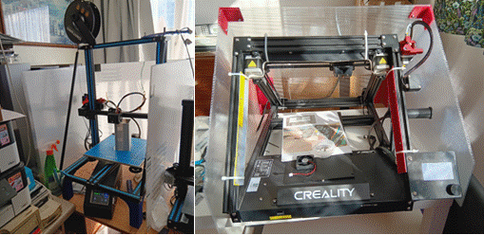

|  |  |
| --- | --- |
| *Draft shield – CR10S printer.* | *Enclosure/shield for CR30 printer* |

* The second example is a Creality CR30 belt printer. Again, this has been made from the same size sheet of polycarbonate. With careful planning, it was also possible to make this from a single sheet with enough remaining for a front cover plate if desired. The resulting enclosure is again pictured above on the right.
* The corner brackets were printed using PLA, secured to the polycarbonate with M4 screws and nyloc nuts. **N.B. There can be significant fire resistance risks with the use of PLA which is acknowledged. This is an area that will be more thoroughly explored and reviewed with the second edition of this document to give time for the issues to be thoroughly aired.**

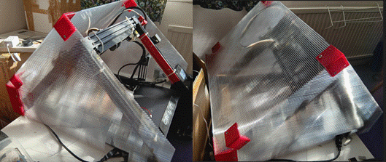

*Illustrating the 3-D printed corner bracket fixings (visible in red)*

**Filtration and filters.**

Self-enclosed filtration systems (e.g. AlveoONE) can be purchased. Alternatively, a homemade system can be made from a bathroom extractor fan and some flexible hose to fit. The outlet should be placed outside of the building to be effective.

Section 14.9 provides links to some of these options.

**Set up**

It is worth making sure that the bed is as level as possible. To assist with this, the printer will come with instructions on initial levelling and setting the initial Z height. Most printers now have automatic bed level detection where the bed is sampled before printing begins, and automatic correction applied for different parts of the bed.

N.B. This step may need repeating as time goes on**.**

**Filament storage**

Some filaments are hygroscopic – they absorb moisture from the atmosphere. The result tends to be that the filament becomes very brittle which may make it impossible to print with. Storing the filament in sealed bags, preferably with silica gel, is worth doing. It is possible to obtain filament driers to restore damp filament.

**Printing**

Getting the sliced artwork file onto the printer is normally done using a USB memory card stick. An alternative is to hard wire the printer to the design computer or to use WIFI or Bluetooth. The interface on the printer will be specific to the manufacturer and possibly the printer model. Referring to the printer manual will help ensure that the connection details are configured correctly.

For prints that take some to print, it is worth checking on the printer periodically. If something has gone wrong, it may continue to extrude plastic into space, producing the proverbial cat’s cradle. The only thing to do in this case is to cancel the print, let it cool down, then try to clean up (being aware that there are often very fine wires exposed on the print head – try not to break these!).

**Post Printing**

Once printing is complete, the print will need to be removed from the bed.

The latest printer build plates are usually topped by thin flexible magnetised steel sheets coated with Polyetherimide (PEI). These will aid the removal of finished prints.

These sheets are also available in different textures to suit specific plastics.

* Smooth PEI plates are recommended for PLA & have great adhesion with many materials.
* Satin Powder-coated plates offer an optimal level of adhesion. A vast majority of materials can be printed without a separation layer (e.g. glue).

These are very convenient. They can provide a somewhat rough finish to the part of the print in contact with the sheet. This may be unsatisfactory if it is a visible surface. On the other hand, a pre-roughened surface will form a good key for gluing if that is what is desired.

Generally, if the printer has a magnetic print sheet, it is just a case of removing this and flexing it to remove the model. However, if adhesion is too strong, working a fine metal blade between the model and the bed may be necessary. This should be done carefully to ensure the blade does not dig into the bed. Another alternative is to heat the sheet from behind to soften the plastic in contact with it before using the blade.

It is also worth noting that, on occasion, print bed adhesion can be too great. This can make it difficult to remove the model without damaging either it, or the build plate even if the printer has a magnetic build sheet. Furthermore, some printing materials, including PLA, have a particularly strong grip, especially if there is a large flat area in contact with the build surface. As noted above, some build sheets are covered with a special plastic coating such as PEI as noted above. Where the print is stuck down too firmly, this coating could be pulled off when attempting to remove the print. Where this is a possible risk, the build surface can be coated with hair spray, or an application of “Elmers School Glue” stick rubbed over the build surface.

Most FDM printers also feature auto levelling where the printer analyses the height of the across multiple points over the surface of the bed. They then make height (Z axis) adjustments as necessary to compensate for any slight variations encountered.

### **Resin Printing**

Resin printing is potentially hazardous and messy. It also relies on computers to make it work. Clearly this is a portent for disaster. Computers and mess are not happy companions. Containment and management are key to dealing with both issues. However, within these maxims there are many potential solutions that will suit individual needs.

**Points to Consider**

Accordingly, a solution needs to be worked out that works for each user and the other occupants of the property.

For the actual printing, a clean area separated from the main dwelling by a door is ideal.

Areas to avoid include:

* Workshops used for machining, cutting, sawing etc. where dust and other detritus are possible.
* Kitchens and living areas.

Studies/offices may be the most sensible compromise. However, they need to be in an area of the property that is completely separate to the rest of the house. N.B. they can be attached but should have a door that can be kept closed for long periods whilst the printer is operating and/or the prints are being attended to. This is because, whilst printing, the printer will give off some fumes which are not healthy. Another problem is that the printer and resin need to be kept at room temperature as well.

The concept of managing and containing potential mess so that it does not spread beyond defined boundary points is key to control the resin printing process. The same applies to hazard management as well.

To achieve this, a routine and system for handling the processes is needed:

The printer itself is a computer and therefore needs to be in a clean place where the electronics will not be damaged e.g. dust, muck, etc. Desirably, it should be close to the artwork computer to allow easy transfer of files by USB.

The messy stages of the process are:

• Decanting and replacing the resin to and from the resin tank.

• Cleaning and maintaining the resin tank.

• Cleaning up and curing the print, post printing.

• Cleaning the IPA cleaning fluid.

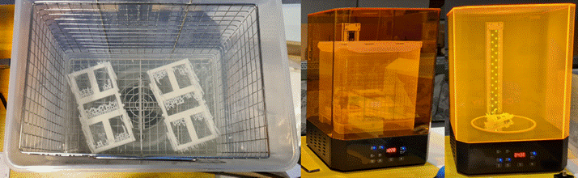

*The stages of finishing prints with the washing process using IPA left and centre, followed by curing on the right in the same machine using UV light.*

**Most importantly, all these tasks should be done wearing old clothes, surgical gloves and a face mask.**

The actual printing time is a completely clean stage where the risk of mess is virtually nil. However, the risk of fumes remains.

**Example Set Up**

One example solution is to have a three-tier system where the individual steps of the process are separately managed in environments that suit:

Firstly, in the study, the computer desk, where the artwork is created, is located beside two further tables. The second of the three, being the table dedicated to the printer, washing/curing machine (additionally other computerised equipment such as electronic cutting machines, etc. can be included here). Thus, they live alongside the computer for ease of access and artwork transfer. The third table is for small scale modelling activities that create low levels of mess. Both the latter two tables are reasonably old, so the odd small spill on these doesn’t matter. For convenience, the three tables are arranged in a U shape. Each can be accessed by simply spinning around on a centrally placed office chair.

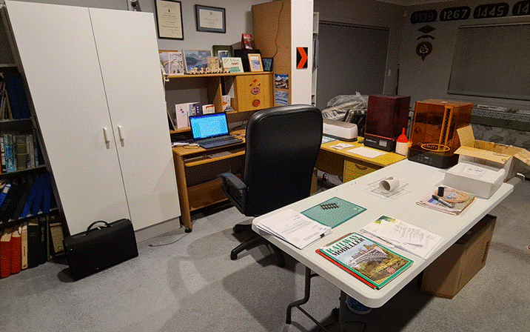

*An example office set up with, from the left, running clockwise: a storage cupboard, the computer desk, the cutter, printer and washer/curer desk and finally, closest to the camera and, remarkably clean and tidy, the modelling desk!*

**Transporting Raw Prints**

To deal with the completed prints, a specially purchased oven tray dedicated to transporting the raw prints is an ideal containment vessel. Before removing the printer cover, the tray is placed immediately in front of the printer. With the cover removed, the build plate, together with the finished prints, is simply unbolted from the printer and immediately placed on the tray. With the cover replaced to contain any further fumes, the whole ensemble is taken to a workshop (the third area) where mess is the norm! Once there, all the necessary work of removing the prints and cleaning up the baseplate are undertaken where the mess doesn’t matter. Naturally, the tray should not see the inside of an oven, its intended function!

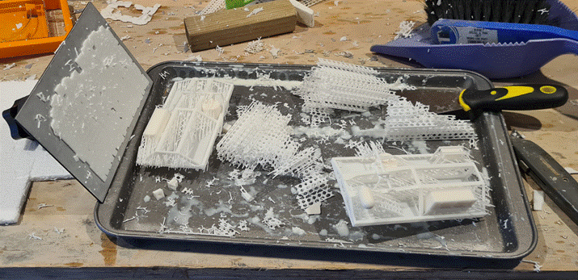

*The oven tray and build plate et al on the workshop bench with two prints cut away from the scaffold. The platform is still stuck on the build plate.*

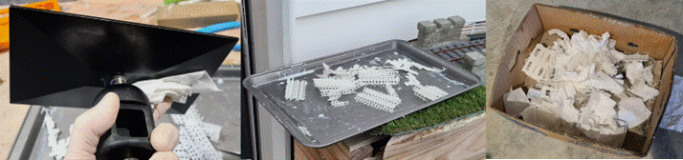

*Left: cleaning the build plate in the workshop: note the gloves. Centre, the discarded debris being cured outside and; right, finally discarded in the dedicated cardboard box for disposal with the general rubbish.*

**Cleaning and Maintaining the Resin Tank**

Pouring resin into the resin tank for printing should be done with the resin tank in place on the printer. Where left over resin is being returned back to its bottle, the bottle rests inside the box it was supplied in, with a large funnel (again purchased from our local supermarket) and filter to receive the resin. This ensures that all the resin goes back in the bottle without difficulty. Any residual dribbles that might escape, end up in the box not the desk.

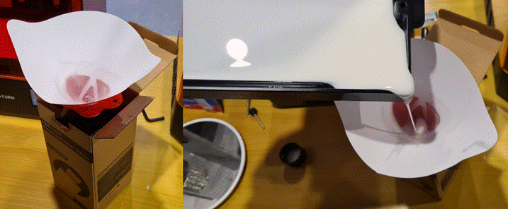

*Decanting residual resin back into its bottle using a filter and funnel (a cheapie bought from our local supermarket). Any spills will flow down into the bottle’s storage box.*

With regard to cleaning up both the build plate and resin tank, toilet roll is a good cheap throw away wipe to remove debris and resin. Sacrificial cardboard boxes are useful to hold these along with scaffolding, used gloves etc. These are kept both beside the printer and in the workshop, and are dedicated to this function. After a reasonable period, they too can be replaced and disposed of.

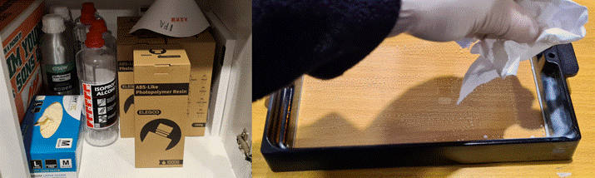

*Storage of materials including gloves, filters, IPA and resin in a dark cupboard (to the side of the computer desk where it is easily to hand). On the right, cleaning the resin tray. Note the clear FEP at the base to let the UV light through.*

**Replacing and levelling the Build Plate**

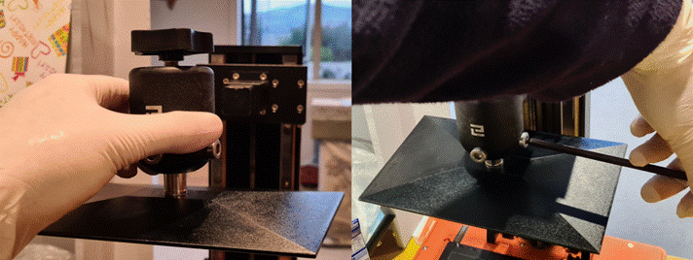

*Refitting the cleaned build plate and slackening off the plate holding bolts to allow adjustment.*

Once the build plate and tray are clean, the build plate needs to be replaced and relevelled followed by the replacement of the resin tray.

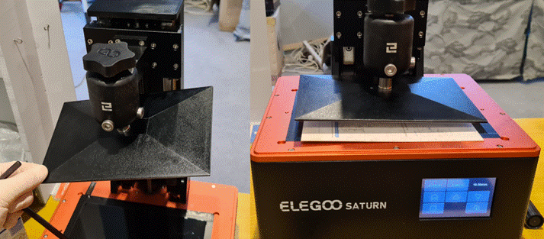

*Checking that the plate is loose on the left and being lowered down onto the glass screen on the right. Note the levelling card supplied with the printer in place on top of the screen.*

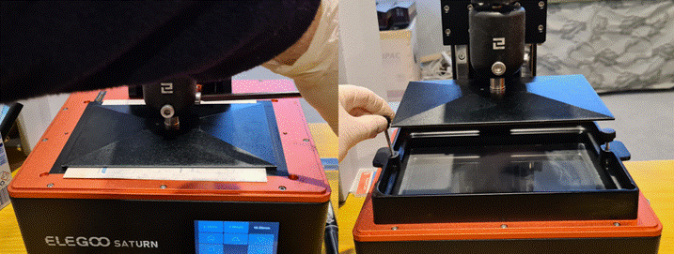

*Tightening up the securing bolts on the left, N.B. this shot is posed and in reality, the plate should be held in place by the other hand as the bolts are tightened up. On the right, with the build plate raised back up out of the way, the cleaned resin tray is replaced and bolted down. The printer is then ready for use once again!*

**Cleaning IPA cleaning fluid**

Inevitably the washing fluid will become clogged and cloudy with spent resin. To deal with this, it is best to leave the cloudy IPA undisturbed for a few days in the tank. During this time, it should clear with sediment falling to the bottom of the tank. It can then be carefully decanted without disturbing the sludge at the bottom of the tank, into the old plastic bottles it originally came in. For obvious reasons it is worth retaining a number of these for this purpose. These then go into the curing machine to cure for 30 minutes before filtering using tissue paper and a funnel (not toilet paper which will dissolve into a pulp).

It is likely that the tissue paper will rapidly clog. Each time it does, it should be replaced.

The filtered IPA should be treated a number of times until it flows through the tissue reasonably well without clogging. This number of times this is necessary depends on how dirty the IPA is.

The empty tank can be cleaned with toilet roll (cheaper still than tissue!).

All the tissues and used toilet roll are put outside for an hour or so to properly cure and then chucked in the cardboard boxes ready for the rubbish disposal.

The cleaned IPA can then be returned to the tank and topped up.

**Conclusion**

It is important to note that the above information is but one way of managing the process. There will be alternate solutions to handling these processes. What is more important is establishing a management system to control the messy stages so that they are properly and safely contained. The exact solutions need to be developed and suited to the environment the printing is being carried out in. The example process will work in the right situation but will not be suitable for every circumstance.

To minimise exposure to the fumes, starting the printer in the evening with completion scheduled shortly after breakfast on the following day (the larger prints can take over 12 hours) is a good idea. The finish time (nominally 08.00) then determines what time the printer is started. Once started, it is left and the separating door should be closed. A towel placed at the foot of the door to prevent fumes entering the rest of the house is also a good move. In the morning, the finish time should be verified. Then, as soon as that has happened, the windows and doors of the printing room can be opened to allow the accumulated fumes to disperse.

An important detail point is that whenever the printer cover is removed to deal with the resin and/or print; windows, doors and curtains need to be closed to remove the possibility of UV light striking the resin tank. Failure to take this precaution can lead to a skin forming on the surface of the residual resin in the tank.

# **Involvement of the Trade and Circle**

## **Design**

It is possible to commission artwork designs. However, this will likely be expensive and require some research depending on the availability of solid prototype information. As many practitioners have found along with other modelmakers, there can be significant gaps in this, often in critical areas of the design!

## **Availability of Artwork**

The Gauge One 3-D Printing Circle offers a number of free to use artwork files in both 10mm/ft (1:30.5) and 1:32 scales. This is available at: <https://www.g1-3d.uk>

## **Availability of Printing Services**

Operating one’s own 3D printer is not the only way to create 3D printed models. There are a number of companies who offer 3D printing services. Some may be 3D printing companies in their own right. Others may be agencies offering access to a wide range of 3D printing companies across the globe.

The benefits of using third party printing services are not just in giving access to 3D printing to those who do not own their own printer. The 3D printers available to a commercial concern can offer big advantages in scale and in the range of materials for printing. SLS and SLM printing technologies are currently not financially viable and/or practicable for most home based amateurs. Using the above organisations makes it possible to have parts printed in a range of plastics including sintered nylon. Various metals are also available, albeit at a price depending on the metal. It is also possible to have larger models, such as entire coaches, printed in one piece rather than in sections.

The disadvantage of having parts printed by a third party is cost. This can be mitigated to some extent by using an agency. Uploading an STL file to one of their sites allows quotes to be quickly obtained from numerous suppliers across the globe.

## **Support**

The Gauge One 3-D Printing Circle provides support in this area of 3-D printing by way of email and zoom meeting forums. More details can be found at:

[The Gauge One 3D Circle | Gauge 1 3D Circle (g1-3d.uk)](https://www.g1-3d.uk/)

Section 14 also provides a number of useful links to guidance notes in various areas of 3-D printing.

# **Hints and Tips**

N.B. Hints and Tips specific to particular forms of printing have been included in the relevant sections.

## **Design Techniques**

### **Part Work Designs**

The benefits of designing the models as a series of part works are:

* File size: software limitations can be best avoided by making each section a separate file.
* Reduced risk when printing: if something goes wrong then only a part or series of parts need to be redone.
* Importantly, there are risks of continuing deformation of plastic prints particularly with resin. This risk can be reduced and possibly eliminated by introducing reinforcing at strategic points either as part of the print or to be inserted later as a separate structural member to restrain the resin from this tendency.
* Practicability. It is possible to print entire units. However, can they then be accessed for cleaning up, further detailing and/or painting?
* Vitally, to avoid ponding and trapping of liquid resin if printing in this medium. This will attack the newly solidified print and soften it. This, in turn, will cause distortion and other damage. It can also lead to damage to the FEP as the distorted print droops down towards the bottom of the resin tank. If the FEP is punctured, uncured resin will then leak onto the glass plate on the top of the printer. Obviously, the leaking resin will also be exposed to the UV light coming up from below and will consequently harden on the glass plate. Nasty!
* Sanding: almost certainly, sanding of joints and any other areas where the surface finish is not as pristine as one would want, will be required. Protruding detail is best left off until this step is complete.

To sum up, the principle of combining 3D printing with other modelling techniques allows the most suitable system/material to be used for each component of the model. Thus 3-D printing is but one of many things used to create the models. However, with its versatility, it is likely that it will be the dominant method for a significant number of the items required given the level of detail and accuracy it delivers. However, for structural strength particularly with plastic prints, the incorporation of metal sheet and angles to give rigidity is a useful benefit. Thus, the resulting models are an amalgam of many materials.

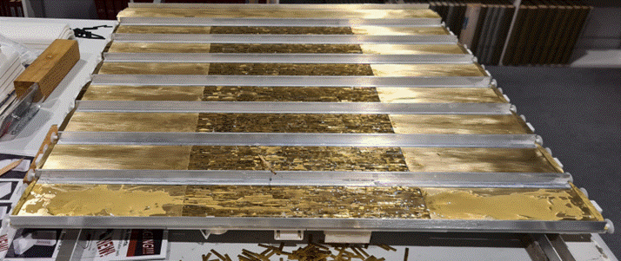

*A batch of eight carriage underframes reinforced with aluminium angles on each side and brass offcuts and sheet in the middle to add strength and weight.*

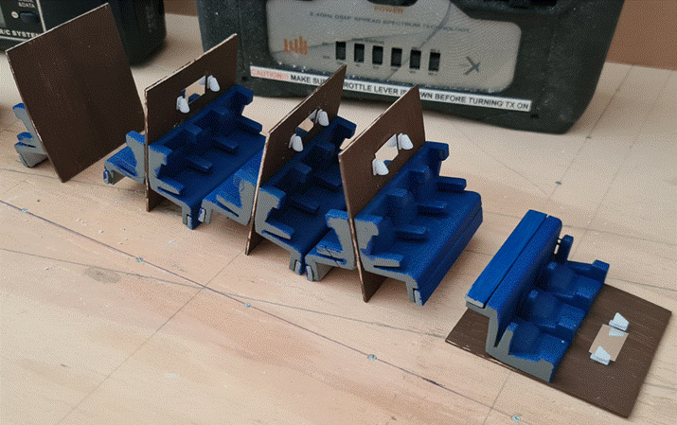

*An example of the use of different systems used to make up components for the main models. These are first-class compartment sub-assemblies with 3-D printed seats and lamps, and 2-D cut 1mm birch ply compartment panels with mirrors (from some plastic mirror sheet found at a local craft shop). N.B. whilst the mirror shape was a straightforward rectangle, there were over 40 of these, so cutting them out electronically saved a lot of time and they were far more accurate than could have been managed by hand.*

### **Use of Lugs and Locating holes**

To easily and accurately locate protruding detail, holes can be incorporated within the artwork for the main sections. Similarly, the detail parts have a spigot added to their base to fit the corresponding hole.

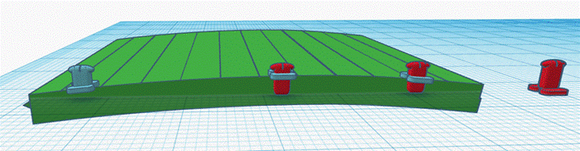

*The creation of door hinges using a curved carriage side as a template. The planks used to create the large radius curved profile are clear. The steps in creating the three types of door hinge are from right to left:*

* *A master.*
* *The bottom hinge with the base plate moved and angled to match the bodyside profile.*
* *Likewise, the centre hinge.*
* *The top hinge on the left has had the excess material beneath the baseplate removed and the balance has been merged together again to form a single object.*

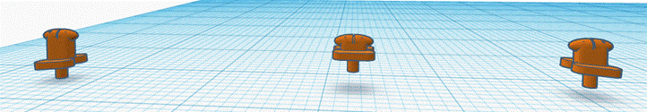

*The completed door hinges with locating spigots added. Note each of the three hinge types are different to keep the hinge pivot points in line.*

### **Creation of Large Radii Curves**

Some basic software programs such as Tinkercad have a number of limitations in the number of facets available to form curves. Where a large radii curve is needed, these limitations can become quite apparent in the form of large flats instead of a smooth profile. To avoid this problem, small segments of the required profile can be created. These are then individually angled and aligned with each other to form a series of flats across the profile of the curve. Once the desired profile has been developed, the segments can be combined to form a single structure. This produces a much smoother profile than the standard curves that the basic software programs are typically capable of. N.B. for small radii items, the program profiles are usually fine.

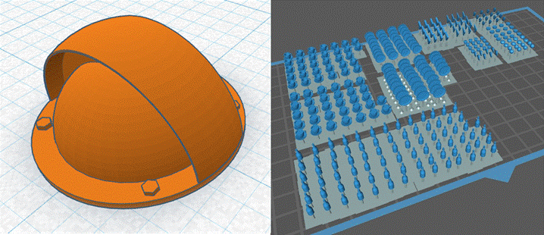

*On the left, a carriage roof ventilator with the curve facets visible. However, in this example these are small enough that they will not show up when printing. Likewise, the culinary artwork, depicted in the printing preparation software on the right, is also small enough for curved profiles to be formed using the software standard shapes. Note the combined platforms to support these delicate and numerous items.*

# **Areas of Interest**

## **What Parts of the Process do you Want to do Yourself?**

As can be seen from the above information, it is possible to use as much or little of the process as someone feels inclined. One can also start gradually and expand one’s involvement as knowledge, experience and technology develops.

## **Artwork Design Experience?**

A person experienced in CAD drawing probably won’t need to read this. However, for a novice, this area can be a minefield and somewhat intimidating. Fortunately, as stated above, there are a number of entry level software programmes with easy-to-follow tutorials to help. Time spent on these is a wise investment. Best of all, most are free as long as there is access to a computer and the internet. There is more information on this subject in the links given in section 14.3.

## **Room to do Printing?**

Going beyond artwork design into the realm of printing definitely requires space and the acceptance of a degree of smell and mess. These things require careful management as outlined in section 10.5. However, with carefully thought-out solutions, this step adds a significant layer of enjoyment and flexibility to the process not available if solely using the trade to do the printing. Whilst there is a degree of capex needed at the start for the hardware, in the long term, these costs will be quickly recovered with the savings resulting from the models made using the process. Furthermore, it is possible that other members of the household will also be interested and wish to involve themselves in the processes to further their creative pastimes as well. There is more information on this subject in the links given in sections 14.2 and 14.4.

## **Availability of Spare Parts and Materials?**

It is worth being sure that there is a readily available supply of spare parts and materials as well as supplier support when selecting the printer and associated hardware and materials.

## **Planning**

This is the key to starting out. Talk to friends and/or members of the Circle about their experiences and ideas. Expect divergent ideas and solutions to problems. There is also information on this subject in the links given in section 14.2. Form your own opinion on all of these thoughts and ideas. There is no one definitive route and opposing ideas can be equally valid. The best route is the one that most suits your needs and desires based upon your circumstances. Most importantly, have fun!

# **Useful Links**

## **Disclaimer**

The following lists have been created without prejudice. Please refer to section 3 for more information on this point.

N.B. A number of the following sites are sponsored by particular suppliers. Whilst this does not negate the technical information offered, it is important to understand that there may be other alternatives to those suggested by the site. However, the research information should still be a useful guide.

A further point is the lists given below are not exhaustive. There are other sites that may also provide useful information.

## **3D Printing Introductory Articles**

|  |  |  |
| --- | --- | --- |
| **Title and details** | **Web Address** | **Sponsor** |
| **Beginner’s Guide To 3D Printing**  **A good introduction to the processes** | [How To 3D Print - Beginner's Guide To 3D Printing - 3D Insider](https://3dinsider.com/3d-printing-guide/) | 3D Insider |
| **A Detailed History of 3D Printing**  **Outlines the development of 3D printing.** | [History of 3D Printing Timeline: Who Invented 3D Printing - 3D Insider](https://3dinsider.com/3d-printing-history/) | 3D Insider |
| **What Is FDM 3D Printing? – Simply Explained** | <https://all3dp.com/2/fused-deposition-modeling-fdm-3d-printing-simply-explained/> | [All](https://all3dp.com/2/fused-deposition-modeling-fdm-3d-printing-simply-explained/) 3DP |

## **CAD Software Selection Options**

|  |  |  |
| --- | --- | --- |
| **Title and details** | **Web Address** | **Sponsor** |
| **Best Free CAD Software for 3D Printing – 2024**  **This goes through options that are suited to 3-D printing and the hobbyist. It appears to be independent.** | [Best Free CAD Software For 3D Printing - 2024 - Manufactur3D Magazine](https://manufactur3dmag.com/best-free-cad-software-3d-printing/#:~:text=Best%20Free%20CAD%20Software%20for%203D%20Printing%201,Creo%20Elements%2FDirect%20Modelling%20Express%20%28Version%206.0%29%20More%20items) | Manufactr3D |
| **16 Best Free CAD Software for 3D Printing 2024**  **This goes through 16 options that are suited to 3-D printing and the hobbyist. It appears to be independent.** | [16 Best Free CAD Software for 3D Printing 2024 - 3DSourced](https://www.3dsourced.com/3d-software/best-free-cad-software-for-3d-printing/#:~:text=Best%20Free%20CAD%20Software%20for%203D%20Printing%20%E2%80%93%20Full%20Round-Up.) | 3DSourced |
| **15 Best Free CAD Software For 3D Printing**  **This provides a useful explanation of the history and development of CAD as well as comparative information on the freeware available to today. It appears to be independent.** | [15 Best Free CAD Software For 3D Printing - 3DGearZone](https://3dgearzone.com/resources/free-cad-software/#:~:text=Let%20us%20introduce%20you%20to%20some%20of%20the%20best%20free) | 3D Gear Zone |

## **Printer Selection Choices**

|  |  |  |
| --- | --- | --- |
| **Title and details** | **Web Address** | **Sponsor** |
| **Choosing a 3D Printer: The Most Important Things to Consider**  **This is independent. However, being written in 2018, it is a little dated. It understandably focuses on FDM printing as a result of this. However, it still provides some useful tips on what to look for.** | [How to Choose a 3D Printer: 3D Printing Buying Guide - 3D Insider](https://3dinsider.com/choosing-3d-printers/) | 3D Insider |
| **Your Guide to Buying a 3D Printer – How to Make a Better Informed Decision**  **This is independent. It does not make any recommendations on particular models. However, whilst covering the basics of resin printing it focuses on FDM printing in rather more detail. Nonetheless, it still provides useful guidance on points to consider. There is also a useful glossary section as well.** | [Guide to Buying a 3D Printer: Guide to What to Look for When You Buy a 3D Printer (3dinsider.com)](https://3dinsider.com/guide-buying-3d-printer/#:~:text=What%20are%20your%20ultimate%20goals?%20Where%E2%80%99s%20the%20best%20place%20to) | 3D Insider |
| **The Best 3D Printer for 2024**  **This makes specific recommendations with pros and cons for each. It also provides some general guidance advice** | [The Best 3D Printer for 2024 (pcmag.com)](https://uk.pcmag.com/3d-printers/36506/the-best-3d-printers) | PC Mag |
| **3D Printer Reviews and 3D Printing Tutorials**  This site offers numerous reviews of various printers and componentry but without making direct comparisons. It also offers printing tutorials as well. | [3D Printer Reviews and 3D Printing Tutorials – (makerhacks.com)](https://www.makerhacks.com/3d-printing/) | Maker Hacks |
| **Best 3D Printers in 2024**  **This site makes recommendations on various printers in both FDM and Resin fields** | [I'm Obsessed With 3D Printers. These Are the Best in 2024 - CNET](https://www.cnet.com/tech/computing/best-3d-printer/) | CNET |
| **How to Choose a 3D Printer?**  This has a useful list on **where to get further information** at the bottom. | <https://www.prusa3d.com/page/how-to-choose-a-3d-printer_229126/> | Prusa |
| **3D printer buying guide**  This has a substantial list of useful questions. However, as might be expected, the options given are all Prusa based. | <https://www.prusa3d.com/category/3d-printers/> | Prusa |

## 

## **Printing Materials**

|  |  |  |
| --- | --- | --- |
| **Title and details** | **Web Address** | **Sponsor** |
| **Guide to 3D Printing Materials: Types, Applications, and Properties** | [Guide to 3D Printing Materials: Types, Applications, and Properties | Formlabs](https://formlabs.com/blog/3d-printing-materials/) | Formlabs |
| **16 Different Types of 3D Printing Materials**  Focuses on FDM products | [16 Types of 3D Printer Filaments: Comparison & List of 3D Materials (3dinsider.com)](https://3dinsider.com/3d-printing-materials/) | 3D Insider |
| **Ultimate 3D Printing Materials Guide** Focuses on FDM products | [Ultimate 3D Printing Materials Guide | Simplify3D](https://www.simplify3d.com/resources/materials-guide/) | Simplify 3D |

## **FDM Infill Densities**

|  |  |  |
| --- | --- | --- |
| **Title and details** | **Web Address** | **Sponsor** |
| **Understanding Infill Density Settings in 3D Printing** | [Understanding Infill Density Settings in 3D Printing - 3DSourced](https://www.3dsourced.com/rigid-ink/3d-print-optimal-infill-settings/) | 3DSourced |
| **Weak Infill in 3D Printing – What Causes It and How to Fix** | [Weak Infill in 3D Printing – What Causes It and How to Fix - 3D Insider](https://3dinsider.com/weak-infill-causes-and-how-to-fix/) | 3DSourced |
| **Explanation of** **infill**, including density | <https://help.prusa3d.com/article/infill_42#fill-density> | Prusa |
| **Review of Infill patterns** | <https://help.prusa3d.com/article/infill-patterns_177130> | Prusa |

## **FDM Printer Nozzle Cleaning**

|  |  |  |
| --- | --- | --- |
| **Title and details** | **Web Address** | **Sponsor** |
| **How to Clean Your 3D Printing Nozzle** | [How to Clean Your 3D Printing Nozzle - 3D Insider](https://3dinsider.com/how-to-clean-3d-printing-nozzle/) | 3D Insider |

## **FDM Support Setting**

|  |  |  |
| --- | --- | --- |
| **Title and details** | **Web Address** | **Sponsor** |
| **How to Optimize 3D Print Support Settings for Better Results** | [How to Optimize 3D Print Support Settings for Better Results (crealitycloud.com)](https://www.crealitycloud.com/blog/tutorials/3d-print-support-settings?source=2) | Creality |

## **FDM Printer Enclosures**

|  |  |  |
| --- | --- | --- |
| **Title and details** | **Web Address** | **Sponsor** |
| **Why make a 3D printer enclosure** | [Why make a 3D printer enclosure: advantages and disadvantages (alveo3d.com)](https://www.alveo3d.com/en/why-make-a-3d-printer-enclosure-advantages-and-disadvantages/) | Alveo3D |
| **AlveoONE filtration system** | [Custom industrial air filtration solutions | High-efficiency air filters (alveo3d.com)](https://www.alveo3d.com/en/custom-filter/) | AlveoONE |
| **Building a Budget-Friendly 3D Printer Enclosure from Scratch** | [Building a Budget-Friendly 3D Printer Enclosure from Scratch (youtube.com)](https://www.youtube.com/watch?v=iefBjew7dYg#:~:text=3D%20Printer%20enclosures%20are%20too%20expensive,%20so%20I%20built%20one) | aka: Matchstic |
| **How to build a 3D Printer Enclosure out of IKEA furniture!** | [Bing Videos](https://www.bing.com/videos/riverview/relatedvideo?q=https://all3dp.com/2/ikea-3d-printer-enclosure-tutorial/&mid=C681F60C2CD08123B70CC681F60C2CD08123B70C&ajaxhist=0) | willcaddy |
| **IKEA 3D Printer Enclosure Hack for Wanhao Di3** | [IKEA 3D Printer Enclosure Hack for Wanhao Di3 (pinterest.com)](https://uk.pinterest.com/pin/231653974564248378/) | Chris Garrett |
| **Enclosures for various FDM printers** | [Search Thingiverse - Thingiverse](https://www.thingiverse.com/search?q=enclosure&page=1) | Thingiverse |
| **Universal 3D Printer Smart Enclosure** | <https://www.thingiverse.com/thing:2792618> | Thingiverse |

## **SLS Printing Processes**

|  |  |  |
| --- | --- | --- |
| **Title and details** | **Web Address** | **Sponsor** |
| **Guide to Selective Laser Sintering (SLS) 3D Printing** | [Guide to Selective Laser Sintering (SLS) 3D Printing | Formlabs](https://formlabs.com/blog/what-is-selective-laser-sintering/) | Formlabs |

## **SLM Printing Processes**

|  |  |  |
| --- | --- | --- |
| **Title and details** | **Web Address** | **Sponsor** |
| **Selective Laser Melting (SLM) – 3D Printing Simply Explained** | [Selective Laser Melting (SLM) – 3D Printing Simply Explained - FacFox Docs](https://facfox.com/docs/kb/selective-laser-melting-slm-3d-printing-simply-explained) | FacFox Docs |

# **Conclusion**

We hope this Guide will prove useful to help you along your chosen path of 3-D printing. As stated in section 6, if you have any concerns, ideas or areas of wisdom that would help us improve this document, please get in touch using the contact outlined in the above section.