Tref’s G1MRA 75th Anniversary Standard 20T Brake Van
Print and Assembly Instructions
V0.3
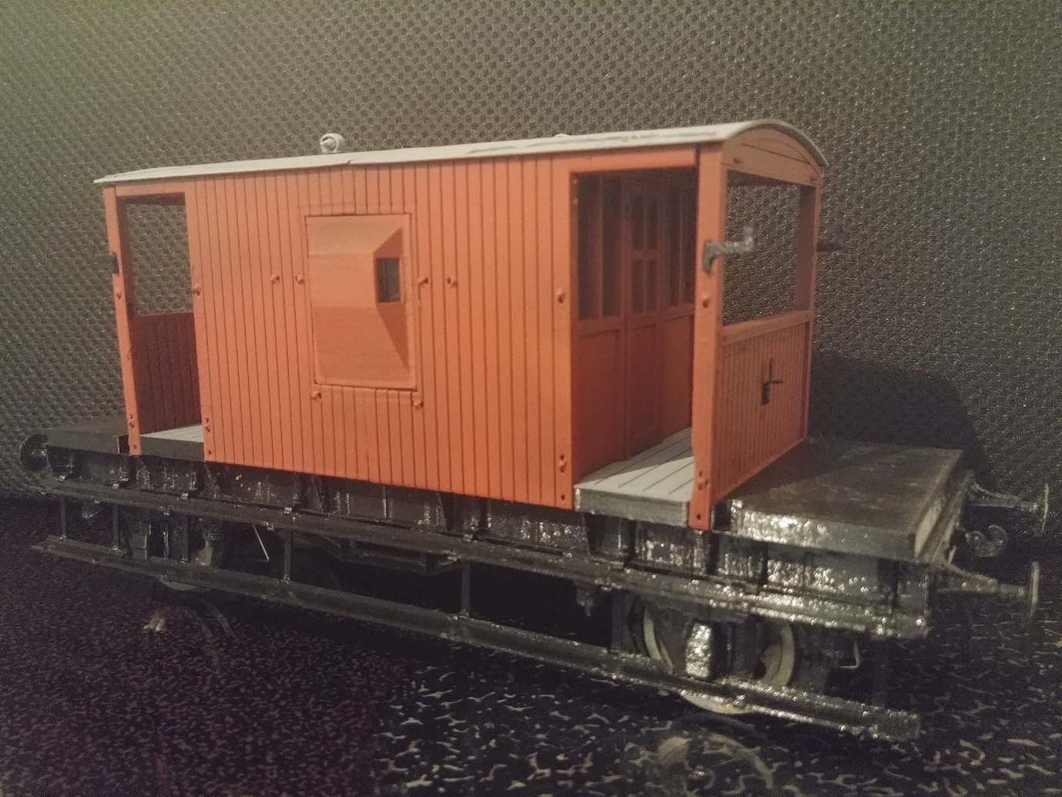A snapshot of how far these instructions will take you, in their current form.

Contents
Contents 1
Revision Table: 2
Introduction: 3
Background: 3
A few words on the Prototype, and which version is modelled: 3
A few details not included… yet! 3
A few words on Materials and printing methods: 4
Easy or Advanced version? 4
Parts list: 5
Tools: 5
Easy Version: 5
Advanced Version: 5
Materials: 6
Easy Version: 6
Advanced Version: 6
Printing and Assembly: 7
Underframe Essentials: 7
Preparatory Work: 9
Underframe Halves: 9
Assembly 9
Underframe Detailing: 11
Preparatory work: 12
Assembly. 14
Interior: 14
Body Essentials: 15
Interior: 21
Preparatory Work: 21
Underframe continued: 21
Handrails: 22
Painting: 22
Appendices: 23
Appendix A – Future works: 23

Revision Table:

Version | Date | Name | Revision
V0.1 |  | TPW | First Release
V0.2 | 28/7/23 | TPW | Added Detail/Change in first stage of Assembly. Revision Table Added.
V0.3 | 4/9/23 | TPW | Revising Assy order base on experience of a couple more builds, and “packs” for printing.
V0.4 | 13/10/23 | TPW | Change from wire to 3d printed handrails

Introduction:

If you are reading this, I am guessing you are considering building or otherwise have an interest in this brake van model. Hopefully you will find all you need to know below, otherwise, let me know or contribute to making this as easy as possible for anyone else to find what they are looking for in future.
Whilst it a was developed as a 1:32 finescale model, it has been modified to accommodate G1MRA standard Wheelset. It has also been test printed at 105% in order to create a 10mm scale version.

Background:

Tref’s G1MRA Anniversary Brake Van Project was a van to celebrate the 75th Anniversary of G1MRA, with a contribution from the 3d Printing Circle.
The Project was to be created in 75 hours, spending no more than £75 over a period of 75 days. Well, two out of the three isn’t bad!
Rather than generic, an actual van was selected to model, which was fortuitously close to me, and itself a restoration project. The custodians have been very generous in their help, and as such, anything left of the £75 at the end of this project is to be donated to them.

A few words on the Prototype, and which version is modelled:

The prototype was built in 1950. Not surprisingly in that time it has seen some repairs and alterations, never mind the current rebuild in preservation. As such it is very difficult to make an “Accurate” model… At the moment it is close to “As Built”… which means no vacuum pipe, vacuum cylinder, but with a stove. It may be update to represent it later in life, and/or preservation, which may mean the Vacuum pipe and cylinder are added, and if as preserved, probably with the stove removed.

A few details not included… yet!

Given limited hours, there are a few details that I would have liked to include, but simply didn’t have the time – I suspect I will revisit them at some point, as their absence annoys me! These are listed in Appendix A.

A few words on Materials and printing methods:

Whilst the kit was initially developed to be available to as many people as possible to build, using as many different types of printer as possible, this became very difficult to manage. Therefore it is now intended to be printed on a filament print, using a 0.4mm nozzle. Other printers (especially resin, particularly for some details) may well be suitable. If you use a suitable filament printer, you shouldn’t have too many problems. The kit was initially developed with a Prusa i3 Mk3.
There are still some components where other methods of construction are much better than 3d printing – namely, wheelsets. There are numerous choices and standards – as far as possible this model has been designed to accommodate all, however not all will fit without modification! The 3d printed wheelsets, coupling chains etc are included to create “complete” model. For more functional use, other wheelsets, couplings, buffers may be recommended. That is not to say that for light use, the 3d printed parts may be adequate.

Easy or Advanced version?

As far as possible this has been designed to clip together, with as much as possible 3d printed. Not surprisingly this introduces some compromises. There are a few items that need to be glued, other parts may optionally be glued. To glue or not to glue is a compromise of allowing parts to be perfectly fitted and more robust for better finish, against ease of assembly, and replacement in the even of damage in service. Not all parts need to be fitted. Once the basic rolling Platform is built, everything else is detail! As far as possible it has been designed such that it can be “upgraded” with as many or as few of the “advanced” parts as you desire. In many cases these can be simply added at a later date, or added with some dis-assembly and reassembly of the relatively simply fitted together components and sub-assemblies. There Is no clear-cut divide between the two – build to the level your skills and patience allow.

Parts list:

- Underframe Half (2 off required)
- Underframe Essentials (12 Parts)
- Wheelsets (8 Parts plus two pieces of Filament, or G1MRA Wheelsets)
- Underframe details (22 Parts)
- Brake Gear (2 off sets required, each comprising 16 Parts)
- Ballast Block (2 off required)
- Interior Floor
- Interior Details (3 Parts)
- Body Details (12 Parts)
- Body Half – Brake Wheel End
- Body Half – Chimney End
- Ducket Pair (Printed as a pair, and separated for assembly)
- Veranda End (2 off required)
- Inner end (2 off required)
- Cabin Door (2 off required)
- Running Boards Set – Full Length (2 off required comprising 10 Parts) OR Running Board Set – Split (2 off required comprising 12 Parts)
- Handrails – Work in Progress

Tools:

Easy Version:
- A 3d printer!
- A 2mm drill bit will be very useful for cleaning up some holes, but probably not essential.
- 3d printed “Finger Drill” chuck makes the 2mm drill bit a lot easier to use.
- 3d Printed Back to Back Guage/Wheel Assembly Jig if using 3d printed wheels.

Advanced Version:
In addition to the above:
- Wire Cutters: Recommend Xuron 2193.
- 3d printed wire bending tool.
- A 1mm and 1.5mm drill bit for cleaning up some holes will be useful.
- Tref’s 3d printed “Finger-drill” Chucks are useful for all three drill sizes.

Materials:

Easy Version:

3d printing filament: PLA or PETG Recommended.
Superglue – other glues may be suitable.
8 off M3 Caphead screws, between 10mm (minimum) and 20mm (maximum) long.
M3 nuts – note Nylocs are not typically recommended (tend to spin in the nut-traps)
If using 3d printed wheelsets, a length of 1.75mm diameter filament.

Advanced Version:

In addition to the above:
No longer any additional recommendations, since 3d printed handrails are now recommended over wire handrails.

Printing and Assembly:

The development of this was carried out on a Prusa i3 Mk3. It has been tested on two such machines, and also a Creality ???
The following instructions assume that it is set up with a standard 0.4mm Nozzle (unless otherwise stated)

Underframe Essentials:
- Underframe Half (2 required):
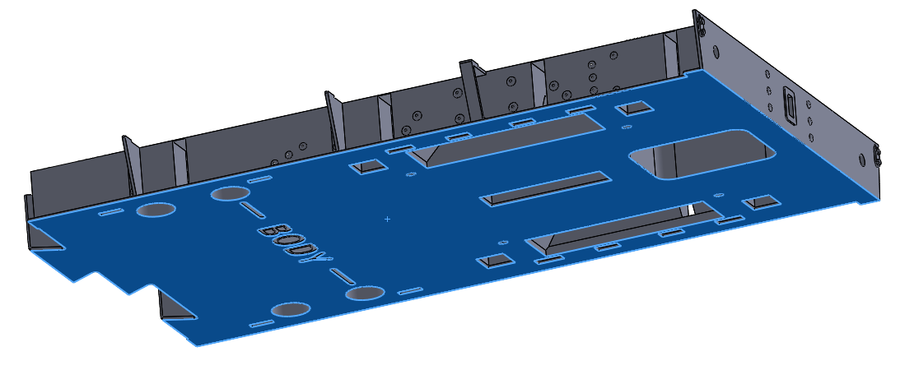
TPW-G1MRA-BR20TBV-007V. This face to the bed. Note if you typically use ironing, it is recommended NOT to use it for this part (results in weakened lugs for the underframe upper half and ballast blocks).
- Underframe Essentials:
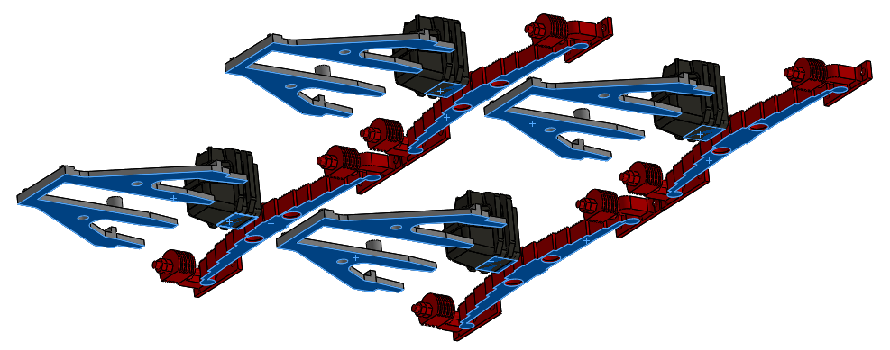 TPW-G1MRA-BR20TBV-121A – Underframe Essentials. This face to the bed.
- Wheelsets: G1MRA Wheelset or 3d printed – 3d printed illustrated, but the G1MRA sets should be a straight substitution. 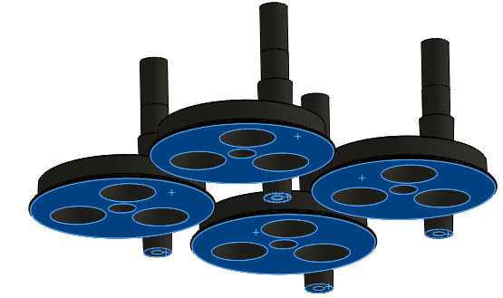”TPW-G1MRA-BR20TBV-123B – Wheelset” – Print with this face to the bed.
- It is recommended to use the Back to Back Guage for ssembly – this is relieved in the centre to stop the wheelset from being glued to the guage! 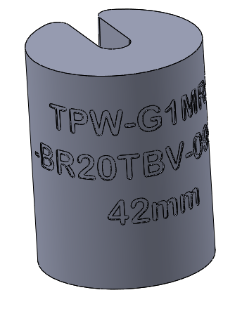Print with either end to the bed. The wheelsets are assembled with a piece of 1.75mm filment threaded down the centre. This can be clipped to length after. 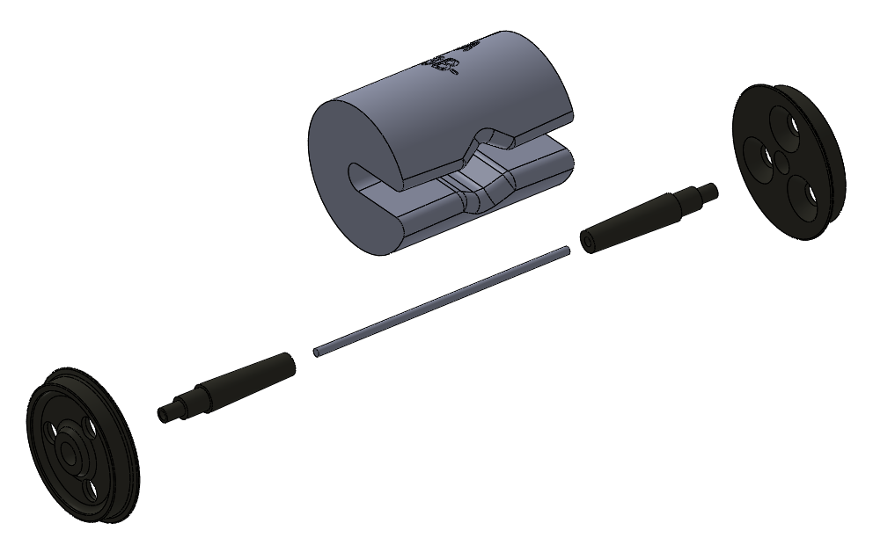
The above represents all the components necessary to create a rolling platform. After this, everything else can be considered detail! However, some of it is pretty fundamental detail to calling it a Brake Van.

Preparatory Work:
- Depending on the Level of Detail you plan on including, it is work doing some preparatory work, namely cleaning up the holes, by running a drill through, for any of the holes in which wire-made components are fitted:

Underframe Halves:
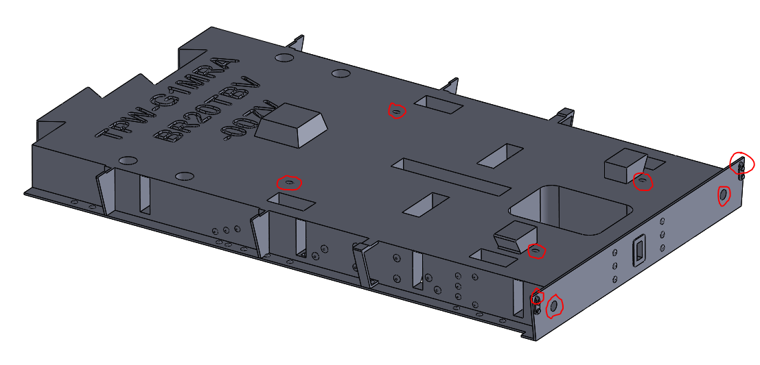TPW-G1MRA-BR20TBV-007V – Holes to be cleaned up. Note the 2mm holes for the Buffers may not need cleaning up – indeed, doing so ensures they will need gluing in place where-as they may otherwise be a “push fit”

Assembly
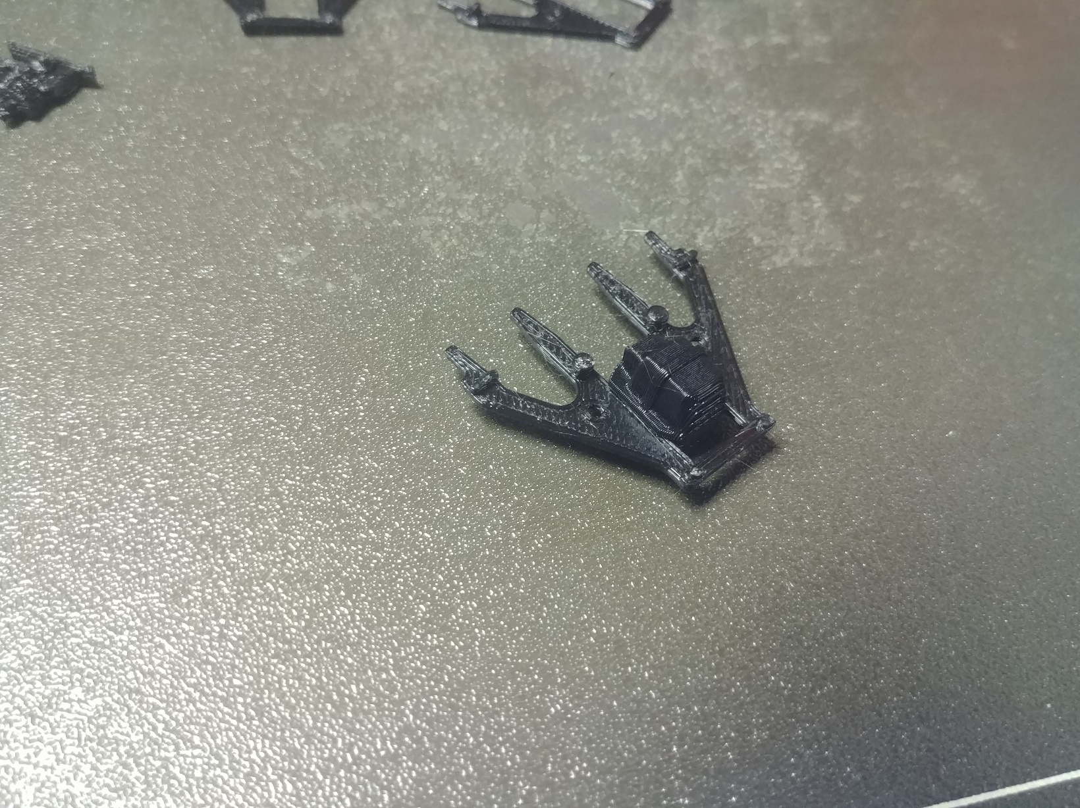
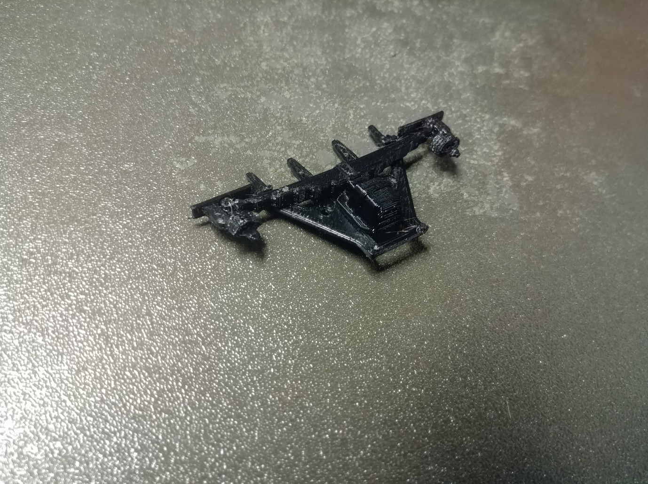
- Assembly. Start by sliding the axlebox onto the W-iron. This is better not glued, as it can then be left as crude compensation, or at least allowed for adjustment to ensure all four wheels are level. The springs can then be clipped onto the W-Irons.
Insert the wheelset between two Axlebox/W-Iron/Spring assemblies, and locate the W-irons into the Underframe halves. It is recommended that the flat of the spring hanger is glued with just a dot of glue at either end, rather than gluing the W-Iron spigots in the holes. This allows for much easier clean-up and replacement should you ever wish to replace them.
Clip the two halves of the underframe together, and the basic rolling platform is complete.

W-Irons:
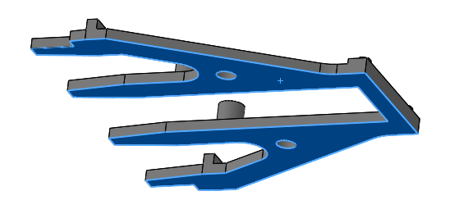TPW-G1MRA-BR20TBV-014G
Axle Boxes:
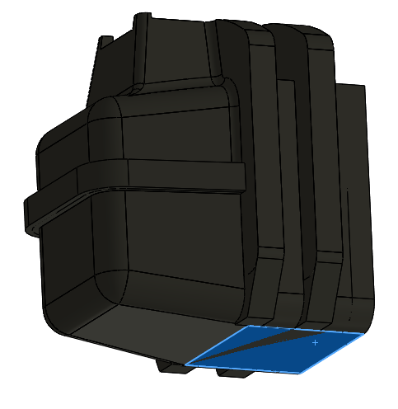TPW-G1MRA-BR20TBV-012E
Springs and Hangers:
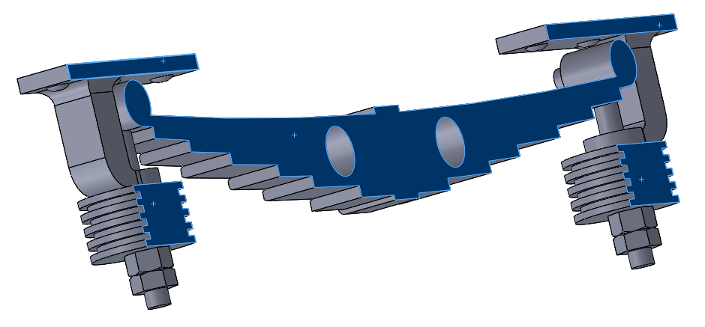
TPW-G1MRA-BR20TBV-025G
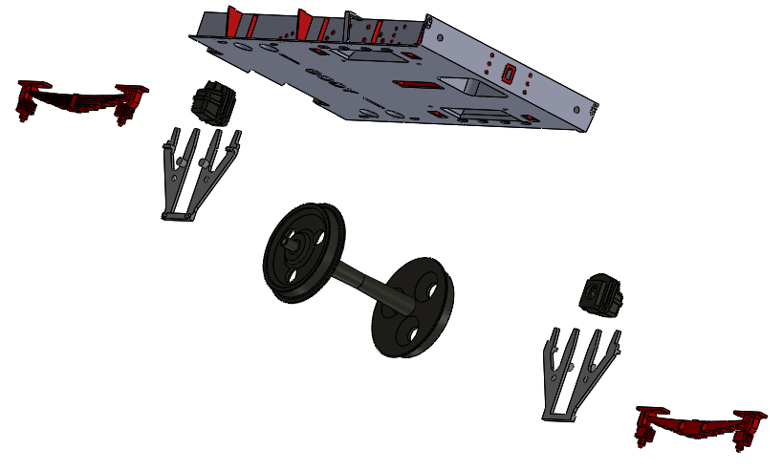
Exploded underframe assembly

Underframe Detailing:
- Underframe Detailing Pack: 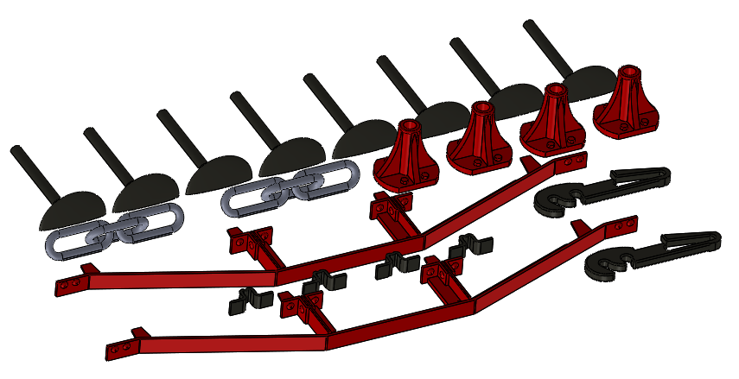TPT-G1MRA-BR20TBV-122A – Underfrme Detailing – Print this side up, other face to bed – no support required.
- Underframe detiling pack assembly:
The buffer halves are best glued together first, and then pushed into the shanks,nd then ito the underframe assembly. These again, are best glued… it is possible to leave them as push fit, but reliability hs not been good, especially as the holes often need cleaning up with a drill. The coupling hooks and chain clip in place without adhesive. The trus rods can clip into place, but again, a dab of glue at the two ends mean should they ever need replacing, the glued syurface is easy to clean up.
The spring helpers are a “glue only” option at the moment – a detail I have never as yet fitted (but worked ok on a previous wagon I designed and built).
- Glue spring assistor/stops to underframe half.
- Press or glue the buffer head to the underframe halves. I recommend just a spot of glue on the back of the shank, not down the hole – this way they are easy to break free , clean up the buffer beam and replace should needs be. Note the orientation – there is a top and bottom.
- Fit underframe trusses – I found one hole needed cleaning out – for this I was able to use a 1mm drill to “pick out” the errant fibre. Again, I put a dab of glue on the face of the truss to underframe, leaving the slot and tab just as a location that will come apart should replacement be required.

- Underframe Upper half and Ballast Block (2 off required):
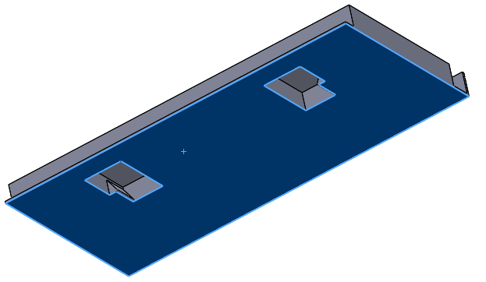
TPW-G1MRA-BR2oTBV-008E. Print this face down) It is recommended that “Ironing on top face only” is enabled on this part.
- Brake Gear Set – 2 off required 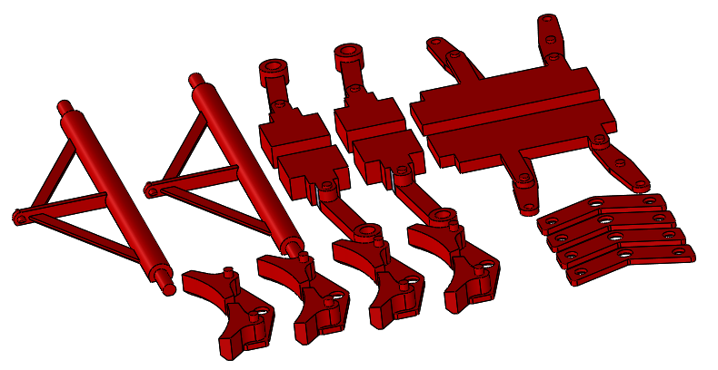
TPW-G1MRA-BR20TBV-124A – Brake Gear Set - Print this way up, no support required.

- Brake Gear

Preparatory work:
Brake Hangers:
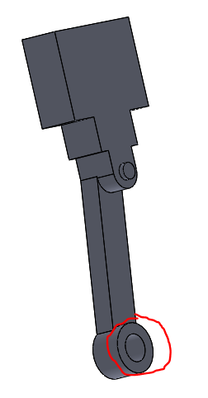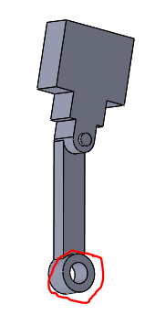
TPW-G1MRA-028C and 077B – drill out hole at end 2mm diameter through.
Brake Equalisation Assemblies:
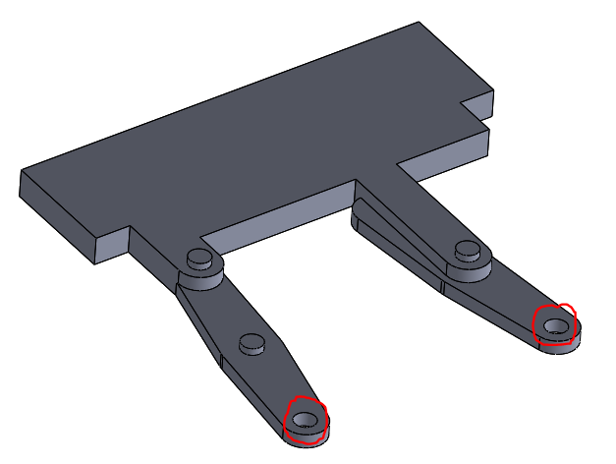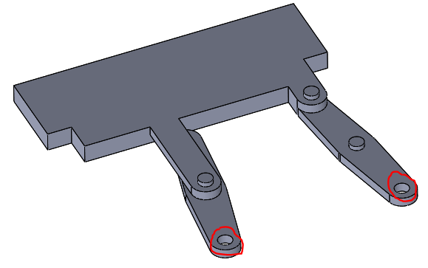
TPW-G1MRA-BR20TBV-041D (LH) and 078B (RH) Brake Equalisation assemblies – clean up holes with 1mm drill bit.

- Brake Gear

Assembly.

With the Underframe on its wheels, drop through the two outer brake hangers, and the two halves of the equalisation assemblies (Note the latter only fit round one way, with the detailed side facing outwards). The Ballast Blocks can then be dropped on and slid to the end of the underframe holding the brake hangers in place. This makes subsequent assembly easier.
Invert the underframe assembly, so wheels upwards.
It is worth checking the fit of the brake block outers on the brake block inners, as they are a fiddly fit in place.

This is probably the fiddliest part of the entire Brake Van assembly.
Put one brake block rear against the wheel, such that the hole lines up with the hole in the brake hanger. Pass the end of the A-frame through both. Note there is an “upside” and “downside” to the A frame… it is recommended to position so that the flat face points up to the underframe.
With one side engaged in the hanger, the other side is now a repeat, except it needs to be more “sprung” in place as it is constricted by the first side. The A frame is then swung around to engage between the two halves of the equalisation assembly.
Repeat this process for the other end, and then again for the inner sets. For the inner sets, drop the hangers into place just before assembly, as they are otherwise likely to drop out… In some ways this makes it more fiddly (stopping them falling out!) in some ways easier (They have a little more “give”).
The outer parts of the brake block assembly are now clipped and/or glued in place onto the brake block inner parts… Again quite fiddly operation.

This completes the assembly of the brake gear and the underframe assembly.

Interior:

Although not needed yet, some of the interior parts are required to be fitted spart of the body, so now is good time to print them.
Floor:
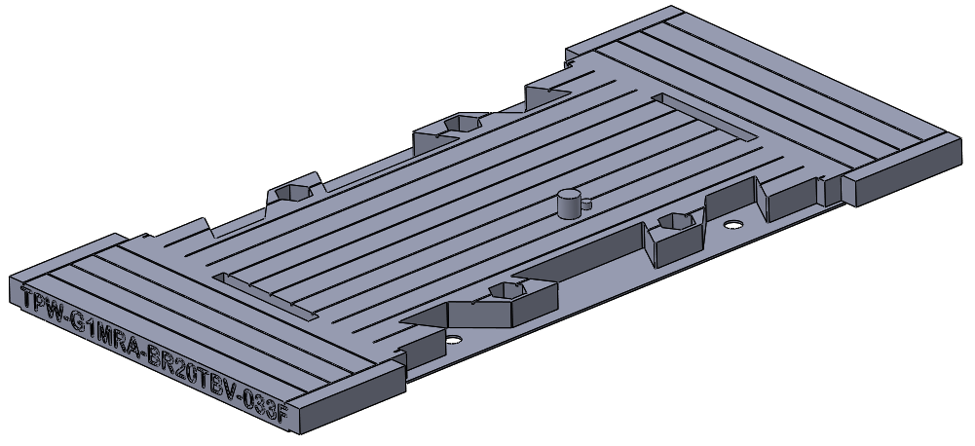
TPW-G1MRA-BR20TBV-033F – Main Floor (print this way up)
Stove: Although it looks particularly spindly, this actually prints surprisingly well. It is, however, well worth turning down the speed once it is above the stove and just printing the chimney. (I have simply halved the speed – this is almost certainly sub-optimal, but you only need one!)

Body Essentials:

Printing and Assembly.
- It is easiest to start with printing the detailing pack, and the veranda outer ends

- Body Detailing Set:
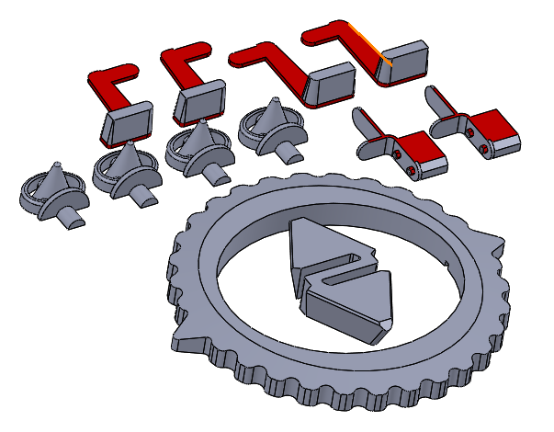
TPW-G1MRA-BR20TBV-126A – Body Detailing Set. (Print this way up, no support required).

- Veranda outer (2 off required):
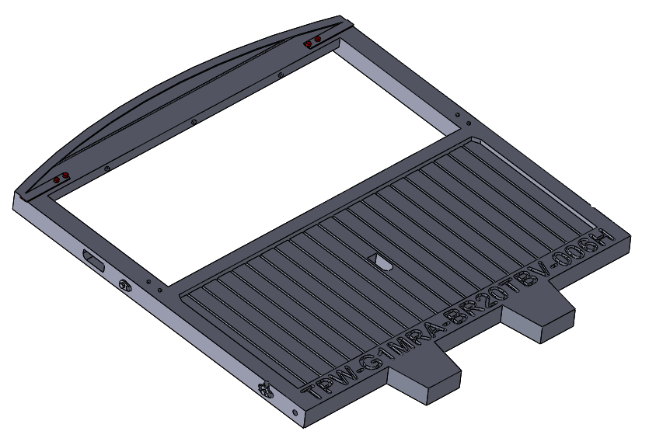
TPW-G1MRA-BR20TBV-006H – Veranda End (Print this way up, no support required).

- Starting with the veranda end, it is easier to fit the lamp irons now, optionally the four vertical handrails too. The side lamp irons can require a fair squeeze to get them home (a pair of pliers is easiest) however, check the slot is clear first – I found a 1.5mm drill ideal for cleaning out. Typically the centre lamp iron is easiest. All are quite fine and easily damaged. None normally require glue. Secure in place.
- Now is also good time to clean out the handrail holes on the veranda ends – there are a total of ten!

- Body. Estimated print time (Prusa i3 Mk3) 3.5 hrs per half. Use “Paint on” local supports as show here:

- Main Body Half – Brake Wheel End: 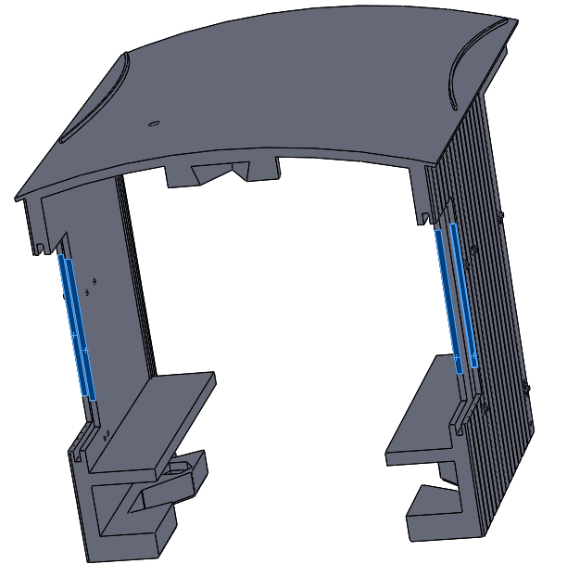

TPW-G1MRA-BR20TBV-004T – Main Body Half- Brake Wheel End. (print with the body split line to the bed. Use “Enforced supports only” on the faces shown here highlighted in blue.

- Main Body Half – Chimney End: 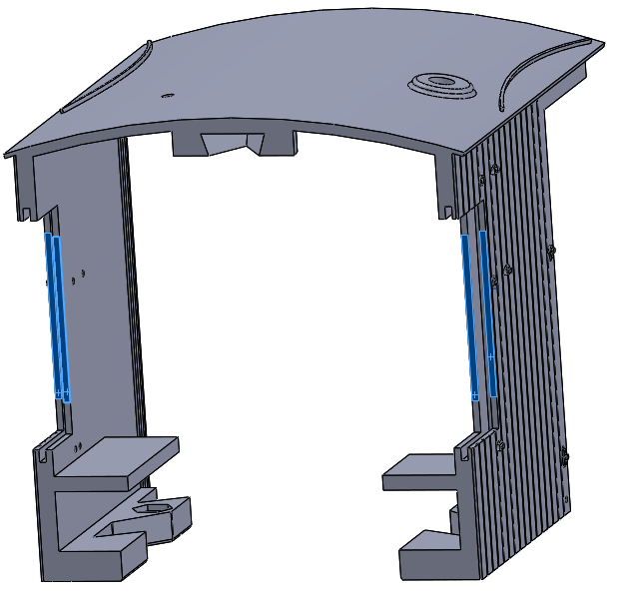
TPW-G1MRA-BR20TBV-055L – Main Body Half- Chimney End. (print with the body split line to the bed. Use “Enforced supports only” on the faces shown here highlighted in blue.
Duckets: 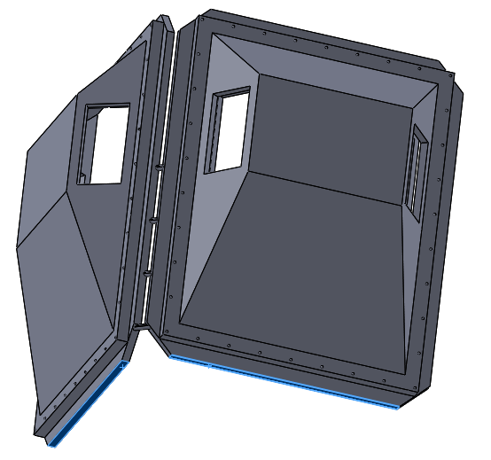 TPW-G1MRA-BR20TBV-030N – Ducket Pair. (print with the faces highlighted in blue to the bed. Support not required.

- Body Assembly:
It is easiest to start by gluing the two halves of the roof vents together, and then gluing them into the body half at this stage.
Now is a good time to fit the nuts into the nut traps. A good method of doing this is to use a socket head capscrew to draw the M3 nut down into the nut trap. The bottom of the traps is slightly tapered, to aid holding the nut in place, however, you may wish to supplement this with a little glue.
Start by assembling the stove and chimney into the Chimney half of the body. This is achieved by sliding the chimney up from the inside through the roof, and then pushing the stove assembly bunker onto the spigot printed on the inside of the body half. It will kind of click into place (but the click is not very definite) It is worth checking that the inner end will slide in place OK to confirm it is home. I will admit this isn’t the most refined fit.
If the duckets are to be glazed, then one side needs to be slid in place as the ducket is fitted to one end of the body. It is suggest that the ducket is held facing up, the body half joining face down, and the two ducket halves fitted to the one end. Once the two duckets are fitted, invert that end, slide the glazing pieces into the duckets, and start to slide the other body half down onto the duckets. Before they are fully home, fit the alignment wedge between the two body halves at the roof level, then fully close the two halves together. The body half retaining ring is then fitted, curved side up towards the roof, with the two pointes pointing towards the outer ends of the van. Once in place over the two lugs, twist the retaining ring so the two pointers point to the sides of the van, inline with the join. This should “tighten up” the gap at the top. Note there my well be a gap at the bottom – this is closed up by fitting the floor, but not yet!

- Inner ends and doors (2 each required): 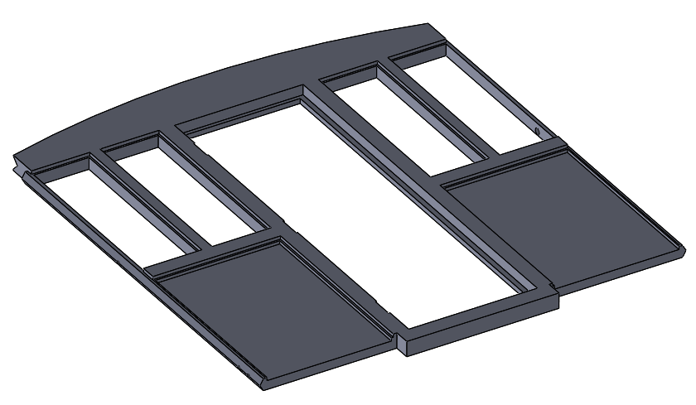TPW-G1MRA-BR20TBV-005E-Inner End (print this way up) Note that the holes in the ends of this print as a slot from the bottom at 1/32 scale, and as a hole in 10mm scale – this is not a concern. They are just clearance for handrail tails, and will not be seen.
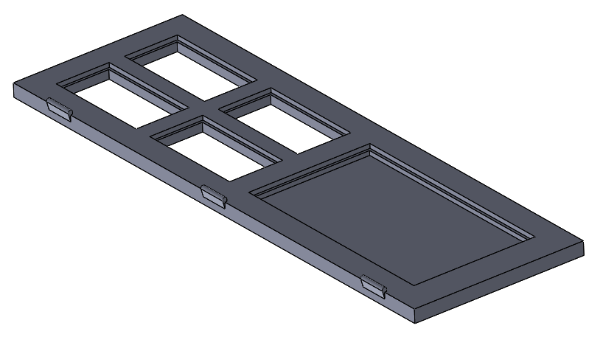 TPW-G1MRA-BR20TBV-034B-Cabin Door (print this way up)

- Body Assy Continued: The cabin doors are a press fit in the aperture in the inner ends – gluing is optional.
The ends are then slid down in the rebates in the body half. At the Chimney end, if it does not slide in cleanly, check the stove and bunker assembly is fully clipped into place.
- Note: The Body has been created in two halves to make it easy to print with minimal support, to use the “grain” of the printer typically in the same orientation as the majority of timber of the prototype, to allow the roof to be printed without awkward to sand “layering”, and to maximise the number of printers that it can be printed on. The compromise is the seam across the middle, particularly prominent on the roof. If this offends the eye, there is absolutely no reason at all why this shouldn’t be treated as a conventional kit, and this area glued, filled, and sanded as any other kit would be!

Interior:

Preparatory Work:

Depending on the Level of Detail you plan on including, it is work doing some preparatory work, namely cleaning up the holes, by running a drill through, for any of the holes in which wire-made components are fitted:
Brake Hanwheel: 1.5mm drill bit

Cabin and Veranda Floor: 3mm drill bit

- Interior: The now is a good time to add the interior details:
- Secure the brake standard to the floor
- Secure the brake handwheel to the brake standard – this does usually require a little glue. The handle would normally have a specific “off” position – I believe towards the outside of the van (to be confirmed).
- Fit M3 nuts to “nut traps” – note they will typicaly be loose – you may wish to either secure them (a little glue) or have them ready to fit when required.

Underframe continued:

- Running boards:
There are two options for the Running Boards – full length, one piece, or split. The full length one piece are the preferred option, however, they may be too long for some printers.
Which ever option is chosen, one set does one side. Note the two running boards are not identical – the lower has cut-outs to the rear for the axleboxes, as per the prototype.
This is the next fiddliest job after the brake gear. Note, they can be just “clipped together”, however, a little glue is recommended, to hold them together as an assembly. Once assembled, they don’t really need gluing into the underframe, although of course, that is always an option if you prefer.
The method I have used to assemble is as follows starting with the lower running bord, clip on two of the brackets at one end. To clip in place, locate the lug on the bracket into the hole on the running bord, and then pivot the bracket up onto the running board.
After the first two or three brackets are on the bottom running bord, fit the top running board to the brackets in the same way, then dd the remaining brackets, starting with the lower running bord, and then clipping into the top.
If one bracket is particularly troublesome, leave it, and come back to it after all the others are in place, or try a different bracket.
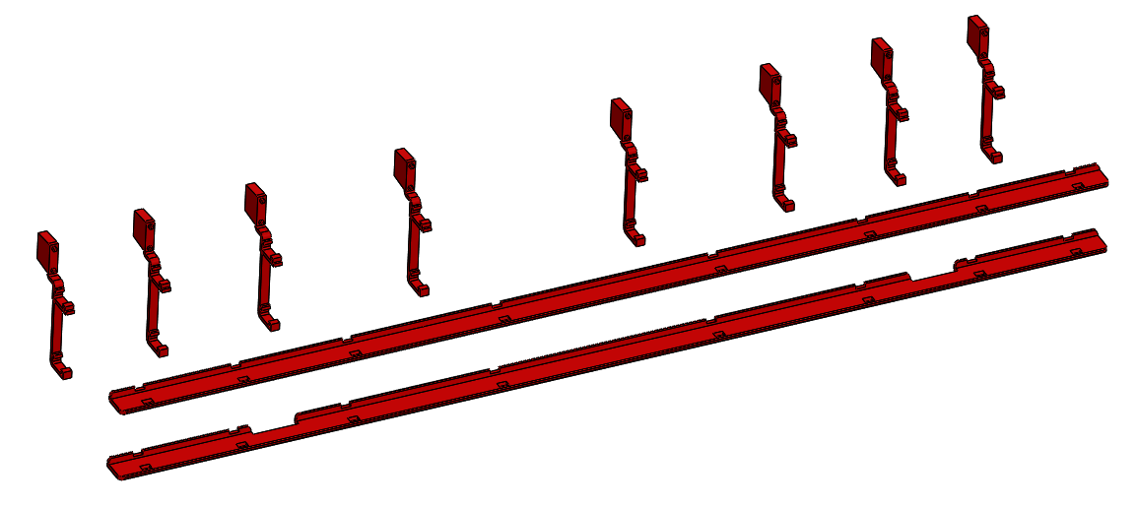
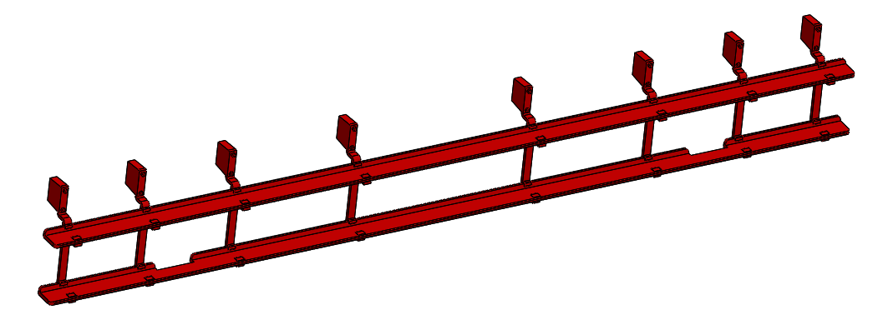Full length running board assembly
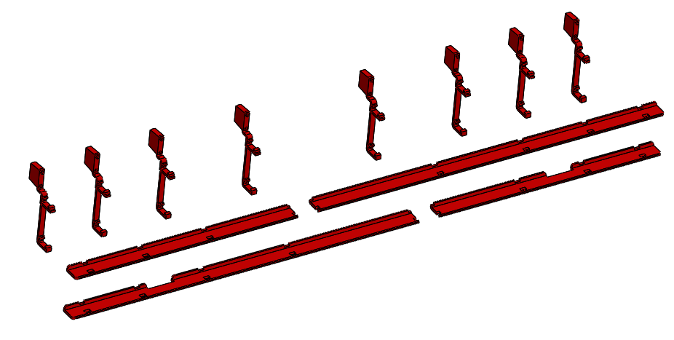
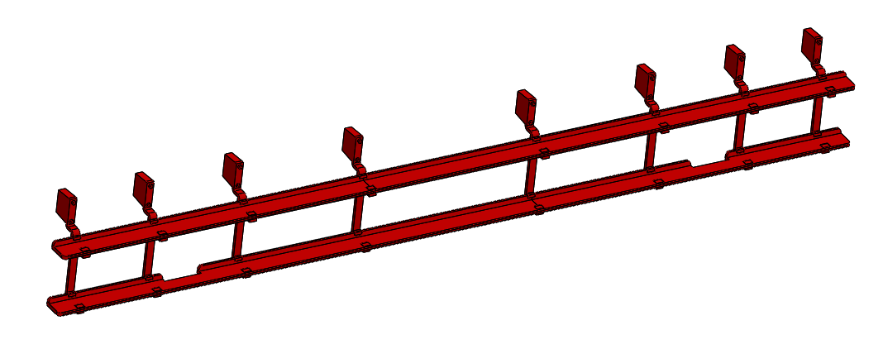
Split running board assembly

- Fit brake rigging safety Loops (spring in place/glue optional).

Whitework:

In a recent revision, all the parts which are typically painted white are now in one build:
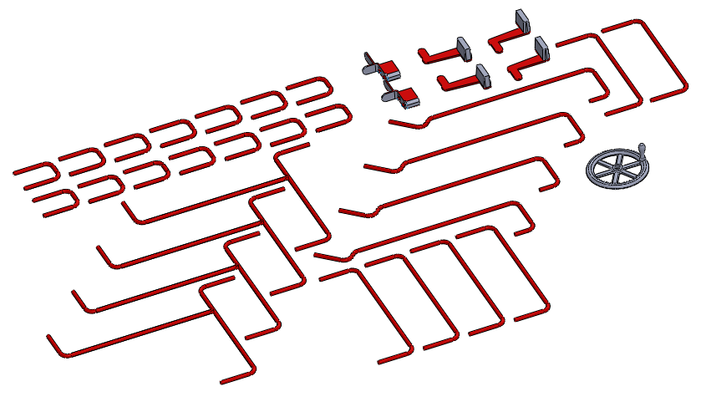
Whilst not everyone is a fan of self-coloured plastic, if these parts are printed in white material, it saves a lot of fiddly painting!

Handrails:
To be completed- the handrails have been revised from MIG welding wire to 3d printed. Some (the “three way” side and the end platform - a total of eight handrail components) are what I refer to as “twist and fit”. They are printed flat, so they print relatively easily, but are then twisted into shape. This has been proven to work quite effectively with both PETG and PLA+, so hopefully you will have no problem. I found it best to “over-twist” to allow for spring-back. All other handrails are just as printed flat anyway.
There is a handrail jig, to ease setting the height of the handrails away from the body:
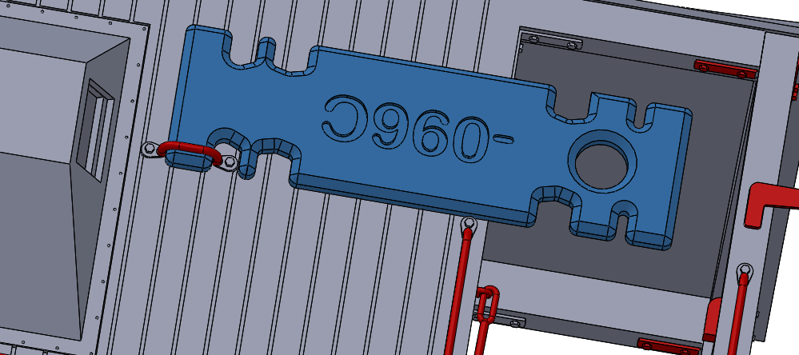
The various slots allow for all handrails to be set, subject to using the correct set of slots. Care is needed to not glue the jig to the body too!

Painting:

I am particularly bad at painting things – it very rarely happens, so these notes are for those as bad as me, not for the expert painters out there! However, a good representation of the proper colours can be made with less than an hour’s work, with three spray cans (available from a well known motoring accessory shop), and a roll of masking tape. If the thought of masking fills you with dread, I literally tore the masking tape to size. If parts are painted at the ideal stages, there is very little masking to do, and the masked edges are hidden from view by other components. The hour I mentioned included masking, and shaking the cans!
Materials I used:
- Halfords White Plastic Primer
- Halfords Grey Primer
- Halfords Red Plastic Primer
- Screwfix el-cheapo masking tape – 25mm
The procedure I followed:
- With the Body Halves bare, except for just the vents glued in place, I sprayed the inside as best I could with white primer.
- At the same time I sprayed the inside faces of: The Duckets, The Inner Ends, The Cabin Doors.
- Temporarily fit the two body halves together, with the Duckets in Place and mask up all except the roof.
- Using the grey primer spray the roof, and dusting over the floor.
- Fit the doors into the inner ends, and mask behind the windows in both.
- Mask the underside of the roof on the veranda ends (but leaving the timbers exposed), mask the top of the roof.
- Temporarily fit the inner ends to the body.
- Spray the body sides, Duckets, and inner ends as one with red primer. Also spray the outer ends at the same time, both inside and outside (before fitting lamp irons)
Note I did no preparatory rubbing down, washing or anything – just straight onto “as printed” PETG. This is not recommendation, just a statement that if you are as lazy as I am, you might just get away with it! I did however, only try and “dust” paint on, not apply a thick coat.

Appendices:

Appendix A – Future works:
Details of elements that are currently omitted due to limited time – the project may be revisited and these included at a later date.:
- Brake safety loops (Now added)
- Vacuum Pipe
- Vacuum reservoir
- Vacuum brake lever (in cabin)
- Glazing – veranda door
- Glazing – veranda Bulkhead
- Glazing – Duckets (Now added)
- Door Handles
- Veranda safety bar catch

